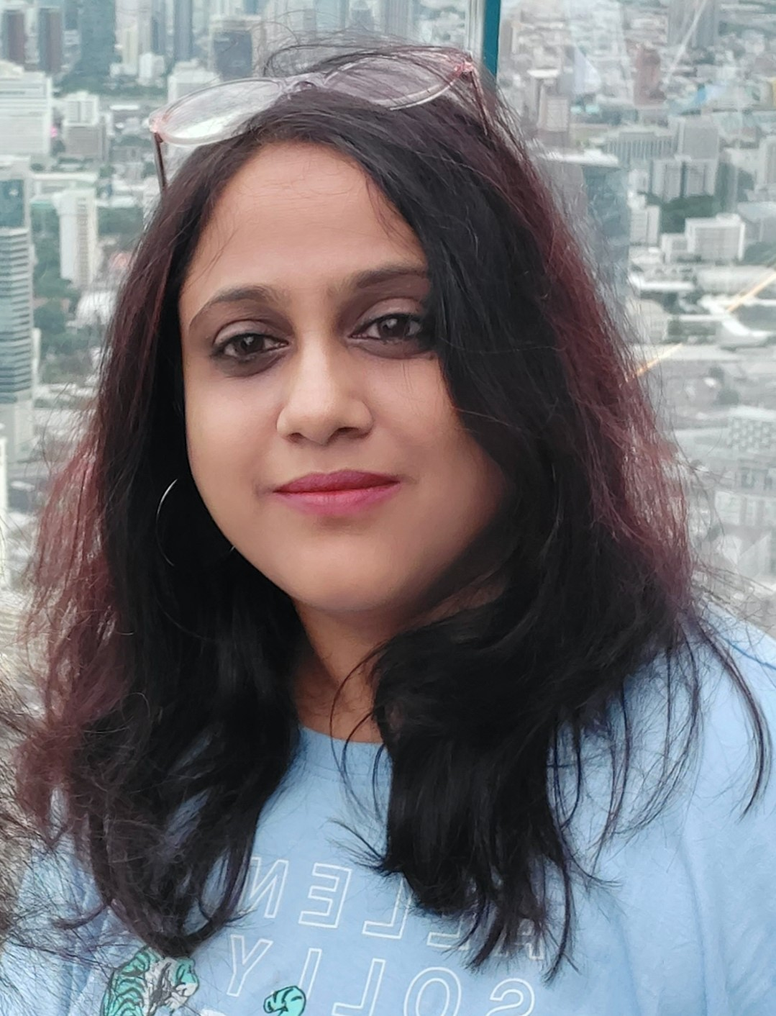

**Shilpi Ghosal**

Digital Product Manager

Bangalore, India

9663212272 · [ghosal.shilpi@gmail.com](mailto:ghosal.shilpi@gmail.com)

 [LinkedIn](http://www.linkedin.com/in/%20shilpi-ghosal-52980324)

## Skills

Product Strategy and Roadmap building

Business Development Strategies building

Market Research Design Thinking

Product Research & Analytics

Prototyping and Customer Validation

Internal & External Stakeholder Management

Agile Project Management

## Hobbies

Music, Travel, Culinary Practices

# Profile

An accomplished product evangelist brings over 15 years of experience in IT, excelling in various roles including product management, product ownership, and BI analytics lead.

With a strong focus on delivering customer-centric products driven by customer insights, have successfully handled end-to-end product delivery in multiple domains, such as banking, software, and engineering.

An innovative and strategic thinker with a proven track record of delivering quality products and garnering customer satisfaction through faster and customer-centric solutions.

# Employment History

## Digital Product Manager, Cargill India, Bangalore

July 2022

* Responsible for defining and evolving the product strategy for the SaaS Platform i.e., Hatching Hope (Digital Platform Solution for Poultry and Livestock across Globe) by continuously assessing the market trends, opportunities, and Competitions in the market in multiple countries.
* Defined both long term and short-term plans to achieve the product vision

and deliver business results.

* Conducted Design Thinking workshop with the end customers and created the customer Journey Maps, User personas, potential product design solutions.
* Created the Information Architecture, Wire-frames and High-level Product Concept, got the idea/concept validation done with the end customers and created the Prototype for the MVP.
* Owned and maintained roadmaps for the product lines for both the Single Tenant and the White label tenants in the Platform.
* Prioritized product roadmap items based on value and data driven approach.
* Ensured consistent execution of features from concept to launch across various product releases.
* Created detailed high quality product requirements documents for the engineering teams.

## Education

### Bachelor of Technology in Computers Science and Engineering,

Odisha Engineering College, Bhubaneshwar (Biju Patnaik university of Technology)

March 2004 — May 2007

## Certifications

**Product Management, Indian School of Business (ISB)**

November 2022 — March 2023

## Certified Product Owner, Scrum Alliance

November 2020 — November 2023

**Advanced Certified Scrum Master, Scrum Alliance** August 2017 — November 2023

* + Conducted multiple Customer Validation sessions with Prototypes/product Concept designs (Figma designs) with real customers and co20+ User testing sessions and tested new features and designs. It helped us to assess the shortcomings before putting it in front of the customers.
  + Developed GTM strategy for the Platform. Worked with our Marketing team

to create marketing artifacts, sales battle cards, blogs, podcasts, and webinars, campaign posters and Incentive driven marketing ideas for the Customers.

* + Developed and tracked Product Analytics Analytical Tools (Power BI) and discussed the outcomes of the Analytics in enhancing or shelving the product with Business
  + Responsible for ensuring the SaaS platform and the first Tenant Module (Hatching Hope) is the right Product Market fit for the 30,000 Poultry/ Farming community in Mayurbhanj

### Selected Accomplishments

* + Conducted and have driven Design Thinking workshops both On site and off site for B2C Customers, to conform User journeys/personas, customer behavior and reiterated on the Customer validations for creating Product designs /concept generating create Customer value. Satisfaction and Business Goals around it.
    - Hatching Hope (Powered by Digital Saathi) - A Global Initiative and Cargill’s Corporate Responsibility Program in multiple countries, with a goal to improve lives of 100 million people by 2030 through production, promotion, and consumption of poultry.
    - Have been working with the Customer Segment of Poultry community of Mayurbhanj district, Odisha targeting 30,000 poultry Community (Poultry Farmers/ Veterinarians/feed millers /Hatchery entrepreneurs) in the first phase.
    - FYT Foods – conducted design thinking workshop with home chefs and bakers from Bangalore in Cargill office premises for the digital Platform for them.
  + o Got an opportunity to work with Heifer International (USA based NGO) closely as an important stakeholder for Cargill and understand the various Digital Transformations programmes being run by them in remote parts of India (Including Odisha and Chhattisgarh) Including Empowering women through Backyard poultry, by working as a single point of contact for them for SaaS Product Platform.
  + Hired, managed, and nurtured a team of 2 Product Managers and 1 UI/UX to deliver products across our portfolios.
  + Have been part of the Product leadership team, partnering the B2C products, providing consultations to the other Product in the Organizations including, design, prototyping, UI/UX, Dog Fooding and product execution.
  + Developed and delivered product i.e., Document Management System for Cargill's external customers like McDonald, etc. as a B2B enterprise Product

## Product Manager, ANZ, Bangalore

September 2017 — June 2022

* Responsible for delivering the key Business outcomes and implementing business strategies for Data Platforms including data and analytical solutions, from scratch.
* Responsible to manage Key Financial Stakeholders, within the organization, and help deliver the business goals to them through the financial product executions.
* Responsible for creating the Product Strategies, by working with Stakeholders and gaining the high-level knowledge of the market, customer persona and their needs and requirements.
* Set up and lead team that built customized reporting. Data, analytical and financial solutions, for Internal clients to strategically leverage data within the Data platforms
* Owned and managed the product Backlogs, prioritized the Product features, aligned, and created Product roadmaps on a quarterly basis for the products.
* Driven the Business outcomes by delivering the backlog Items with the Development teams, testing the outcomes/deliverables with the

Stakeholders, garnering feedback with them iteratively and helped shaping the product Goals through the execution of MVPs/MMPs and Product enhancements.

* Managed Quarterly EVM to monitor and prevent the conditions for under/over budget.
* Embedded culture of learning, empowerment, rapid experimentation, adaptability, and collaboration for the product teams, that I have worked with.
* Conducted Planning and estimation sessions, including capacity for the deliverables, through the Sprint planning and other Ceremonies. Help the Product team to come up with the Definition of Done, Definition of Ready, Classes of Service, and other artifacts of Quality and Continuous Improvement.
* Guided and coached the Product team follow the Agile/Scrum principles and practices that work best for the team.
* Improve the flow of work, enabling delivery and helping foster a strong team culture, helped the team to inspect, adapt, and self-assess to continuously improve delivery.

## BI Analytics Lead/Solution Architect, ANZ, Bangalore

August 2014 — August 2017

* Identifying the BI tool for the Analytics to be created from the Various Reporting tools available within ANZ by comparing cost, BI Capability, effort, Skill etc.
* Designing solution for the BI and ETL in terms of Data model, ETL design, Security design and overall design perspective.
* Identifying and providing Infrastructure, required implementing the given solution.
* Working with then build team and guide them during the process of build and execution of the solution.
* Gathering of Requirement and analysis of the same from the business process Team.
* Working with the various Representatives from the Business to decide on the Dashboard layouts and the reports Formats.
  + Creation of. Qvw and .Qvd files from various data sources (Database tables, XML, Excel, Qvd files etc.). Created Dashboard Layouts, Charts, Tables and Report Objects, Load Scripts IN QlikView and Qliksense Reports
  + RPD design from scratch i.e., building of the Physical layer, BMM layer and Presentation Layer.
  + Implementation of the Security set up for the Dashboard and Report data through the RPD, WebLogic Console and Enterprise manger by Creation of Roles, Groups and users and assigning Roles in RPD, Answers and the database.
  + Creation of Calculated measures in BMM Layer of the repository.
  + Creation of Creating the Dimensional Hierarchies on Specific Dimensions.
  + Good understanding of Extraction Transformation and Loading Concepts.
  + Very good understanding of Star and snowflake schema models.
  + Good Knowledge of Slowly Changing Dimensions, Confirmed Dimensions

## BI Lead, Oracle India

July 2012 — August 2014

* + Responsible for design, configuration, development, testing and implementation of Data warehousing and Business Intelligence Applications.
  + Worked extensively in the analysis and development of Data warehousing applications using OBIEE 10.1.3.x and OBIEE 11.1.1.7.
  + Strong experience in developing OBIEE reports (Dashboards) with various functions on OBIEE Web in different views/layouts.