**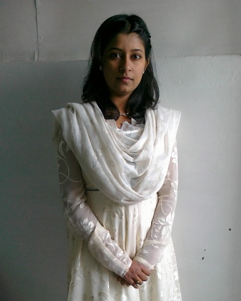*Akansha yadav***

akanshaayadav@gmail.com

+91-7414888531

**Career Objective**

I aspire to develop my skills as a professional and broaden my legal aspects by working in a challenging and dynamic environment and contribute to the best of my knowledge.

**Area of Specialization**

legal

**Academic Qualifications**

|  |  |  |
| --- | --- | --- |
| **Qualification** | **Year of passing** | **Board/University** |
| LL.B | 2008-2010 | Bareilly college, Bareilly |
| B.Sc | 2008 | N.M.S.N. dass college ,budaun |
| Intermediate | 2005 | Kedarnath girls college, Budaun |
| High School | 2003 | T.T Convent school, Budaun |

Throughout first division

**Working Experience :**

2 year experience in handling civil and criminal matter.

Having knowledge in property matter also.

**Personal Details:**

**Date of Birth :** 13th july 1987

**Father’s Name :** Mr. mahendra pal singh advocate

**Marital Status  :**Single

**Languages Known  :**English & Hindi

**Leisure Pursuit           :** Listening to Music, reading, Travelling

**Address                         :** adarsh nagar, civil lines, Budaun (U.P)-243601

STRONG POINTS : HARD WORKING, HAVE GOOD CONCENTRATION POWER

WEAK POINT : EMOTIONAL

**[Adv.Akansha yadav]**