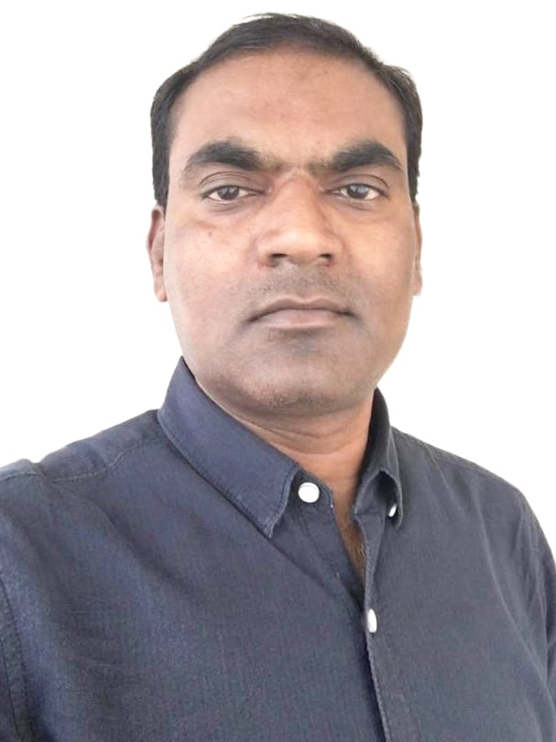**CURRICULUM VITAE**

# SANJAY KUMAR

SF-1, L-74, Sector 12, Pratap Vihar, Ghaziabad.

**Email:** sanjay.piyush73@gmail.com

**Mobile: +91** 9818039011

## Career Objective:

To work in a challenging environment, where I can contribute my knowledge and skills of **Finishing &Packing** for overall development of the organization resulting in the growth of self. More than 17 **years** of working experience in the Garment export industry in the position of **Finishing Manager** in both Knits and Woven.

## Key Skills

* Team leader and keep a high motivational level of subordinates.
* Planning of delivery as per the schedule of shipment mode.
* Monitoring the targets as per the operation bulletin.
* Knowing all type of chemical which is used in process of washing.
* Manpower controlling with the discipline to concentrate on their work.
* Monitoring of daily efficiency, costing & quality.
* To handle daily uncertain environments of industry like absenteeism, attrition rate by design & implementing training of employees for skill enhancement by keeping expected productivity under accepted quality level.

## Working Experience

Presently working with **M/S SHAHI EXPORTS PVT LTD** from July 2021 till date.

Shahi has grown to become India’s largest apparel manufacturer and exporter.

Buyer handled:- J.C. Penny , K-Mart, Target, Kohls, Lands’End and H&M

* Handling Finishing & Packing unit with manpower of 300 employees and output of 15000 pcs per day.
* Daily meeting with supervisors and make line plan.
* Involve in running production for quality review.
* Given quality feedback in the initial output of production pcs.
* Involve in buying agency activity/PPM line walk/mid/final.
* Manage WIP wherever required.
* The main objective is to finish goods as per customer expectation for its quality and delivery with optimized labour.
* Daily report to management for pack status.
* Worked with **M/S PEE EMPRO EXPORTS (PVT) LTD**. From Oct 2019 to July 2021.the company is manufacturing the garment on the large scale and having quality award from the ISO 9001-2000, Buyer handled: - Gap, Old Navy & A&F.
* Handling Finishing & Packing unit with manpower of 100 employees and output of 5000 pcs per day.
* Daily meeting with supervisors and make line plan
* Involve in running production for quality review.
* Given quality feedback in the initial output of production pcs.
* Involve in buying agency activity/PPM line walk/mid/final.
* Manage WIP wherever required.
* Worked with **M/S ORIENT FASHION EXPORT (I ) PVT. LTD**. From Nov. 2013 to OCT 2019.

The company is one of the premier Apparel (Knits &Woven) export organization in India. Operating out of 6 production centres in Delhi. All their factories are equipped with the latest machinery and have production output of over 6,00000 pieces/month.

* Buyer handled:- Esprit, Dillard’s, Lucky Brands, Nordstrom, Justice, Abercrombie & Fitch, Lands end, and many more European Customer.
* Handling Finishing & Packing unit with a manpower of 150 employees and output of 6000 pcs per day.
* Handling 200 to 250 styles/season.
* Involve in buying agency activity/ PPM / Line walk/ Mid/ Final inspections.
* Worked with **M/S SARITA HANDA EXPORT PVT. LTD.** As an **Asst. Manager Finishing/Packing & Logistics** from Aug 2010 to Nov 2013. Sarita Handa Exports is one of the largest manufacturers and exporters of high end, value-added home textile products. The company is based in Manesar Gurgaon with In-house facilities for design, production, and finishing with a production capacity of around 12 crores worth shipping in a month. The company has the latest technically equipped production facility required to service any global high-end customer.
* Buyer Handled:- Macy’s, Pottery barn, Mother care, LL Been, Lands end, and many more US & European buyers.
* Worked with **M/S. ORIENT FASHIONS EXPORT PVT. LTD.** As a **Finishing Incharge** from Nov 2005 to Aug 2010.
* Buyer handled:- Target, Belk, Kohl’s, CSI, J.C. Penny, Gap, Reliance, Biba, W-House, ITC, Ginni & jonny, Westside, etc.

## Personal Details

**Father’s Name :**Late Shri. Ram Shanker

**Date of Birth :**8th, August, 1973

**Marital status :**Married

**Educational Qualification :** Graduation (B. A. from Kanpur University)

**Language Known :** Hindi, English.

**Salary Expected : Negotiable**

**Interest**

To learn and apply intelligence, ensuring improved productivity with maximum utilization of available resources. To learn and improve people's management skills, resulting in improving efficiency. Open to traveling and working abroad.

**Date:- / /**

Place:- …………...

(SANJAY KUMAR)