

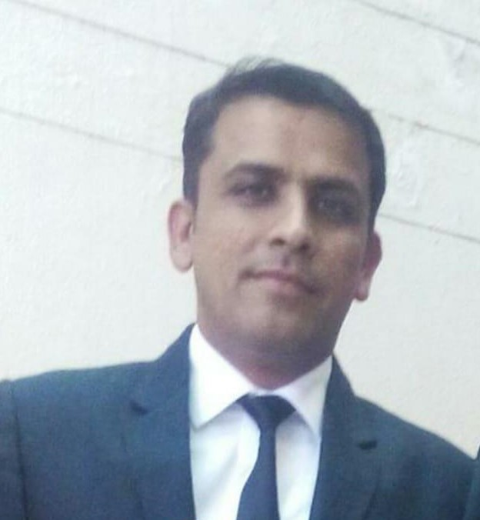

08901081721

BAHADUGARH, India, 124507

[robby_jaz21@yahoo.com](mailto:robby_jaz21@yahoo.com)

https://www.linkedin.com/in/ -singh-joon-359722206

**Jasvir Singh Joon**

RE I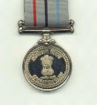G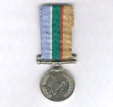 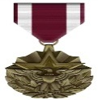

**EDUCATION**

2009-2013 **MBA (HR)-** *Madurai Kamraj University,*

Madurai, Tamilnadu

2007-2013 **LLB -** *Andhra University,* Vizag-A.P ,

1999-2005 **GRADUATION**, *Indira Ghandhi Open Univesity,* Delhi

1996-1997 **12th** *CBSE Board, K V Malakupuram,* Vizag-AP









**CERTIFICATE**

**ABOUT ME**

Dedicated soldier with over 25 years of experience in supervision, operations management, training, administration, and cross-functional communication & an experienced Naval Veteran of three dimensional force with 16.5 Yrs. of respectful service & 2.5 Yrs. served in Russia (for Special project) & now continuing with 9 yrs. of factory corporate functioning in HR, IR, Admin ,fire & safety management.

2005 **COP (Certificate of Proficiency in Russian Language)** (SFL) Govt*. School of Foreign Languauge,* New Delhi

2011 **DISFM (Diploma in Industrial safety Management, Fire Fighting Technique & First Aid)** National Institute of management Studies, Bangalore

2013 **Certificate Course in Business Management** Under DGR,Ministry of Defence, Bangalore

**WORK EXPERIENCE**

**1997-2013**

(Jamnagar, Goa, Mumbai, Chennai, Andaman & Nicobar, Vizag, Delhi & Russia)

**INDIAN NAVY**

**Operational Head**

An Experienced Naval veteran of three dimensional forcé with over 16.5 years of respectful service and served 2.5 yrs in Russia (For special project).

**Roles &Responsibility**

* Managing men & materials on boards ships & establishments.
* Handling performance appraisal process & initiating rewards and recognitions programmes for Ceremonials day
* Managing the complete administration of the canteen/Gas agency, Departmental store & commercial complex.
* Carrying out board proceedings & statement of cases for procurements; liaising with military engineering services & various departments for the finalization of deliveries as per the services levels.
* Implementing disciplinary norms & guidelines for minimizing violations of rule & regulations.
* Firefighting & escape route drills for quick response during crises & emergencies in submerged conditions.
* Formulated budgets & maintaining statutory books of accounts and streamline internal control systems.

**SOFTWARE**

* Excel
* PowerPoint
* Word

**LANGUAGES**

Hindii: Native

English: Fluently

Russian**:** Proficient

**MY STRENGTH**

* Creative Thinking
* Quick Decision Making
* Cost Optimize
* Discipline
* Result Oriented



**INTERESTS**

* Swimming
* Athletics
* Dance
* Listening music

# ADDITIONAL INFORMATION

* Sports Achievements Bronze Medal in KVS National Swimming Championship.

**INDIAN NAVY**

**Achievements**

* Selected for Diving Course & adjourned the best diver.
* **Took part in various war patrols & conquered like Kargil**
* Organized flood relief camps & save many lives.
* Adjourned the best sports of year in 1999, 2007, & 2009.

**SOMANY CERAMICS LIMITED**

**Administration Head**

Post Retirements got oppurtunity to join Somany Ceramics Ltd. In Admin & HR dept. & acquired 9 years of Factory as well as Corporate experience .

**Roles &Responsibility**

* Manging HR Activities of plant, Housekeeping Management, Guesthouse & transport to fulfill all operational needs.
* Meticulously handling overall Administration, Facility Management & security management of Somany Plant at Kassar, Delhi, Gurugram and Corporate Office at Noida.
* Maintaining legal compliance as well as leading role in recovering balance amount from company employees who left company without completing their F&F by filling legal notices.
* Liaison& coordination with Govt. bodies like DC, ADC, SDM, SP, DSP, SHO’s, Tehsildar, Fire Officer, HSIIDC etc. for various statutory compliances.
* Conducting ISO 22000 Audit, 5’s, OSHAS & other Audits.
* Budgeting, Planning, Organizing, cost effectiveness and executing all events /meeting.
* Meticulously handling Fire Safety activities of Plant, conducting Mock Drill and Fire Safety Training & conducting Safety meeting quarterly, Processing for fire NOC etc.
* Responsible to share the MIS with management on savings and cost optimization and share the information about Cost Effectiveness and cost Control Initiatives to reduce the cost

**Achievements**

* During Covid pandemic, we distributed 1000 meals/day to needy peoples in Bahadurgarh locations in collaboration with local administration.
* Initiated VMS (Visitor Management System) for smooth functioning of operations.
* To control over traffic movement in our plant, divided raw materials vehicles & loading vehicles in two groups and provided separate access. Which facilitated increase in dispatch by 50% during month end peaks.
* New project (DFF-1 Plant) successfully completed on time with zero accident & with all statutory compliances.
* Maintain all legal compliance & obtained Fire NOC for three years.
* Controlled theft cases by different tools & tactics.
* Removed over 100 tons of scrap unused scrap from the entire premises in a cleanup drive.
* Made separate shades for scrap segregation and disposal system in a central place.

**1997-2013**

**2014-Till to date**

(Bahadurgarh-Haryana)