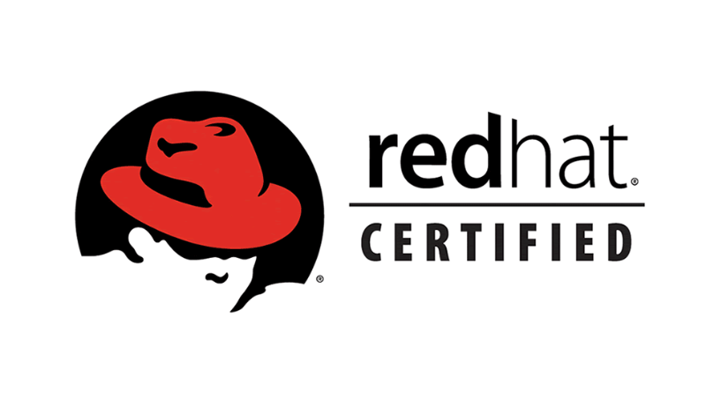

**Archana Chaudhary**

**E-mail: chaudhary.archana3@gmail.com Mobile: +91-9821057798**

***Targeting assignments in Linux Administration/ Linux Engineering with an organization of repute***

|  |  |  |
| --- | --- | --- |
| **Core Competencies**  ***Linux System Administration***  ***Server Management***  ***System Upgrade/ Support***  ***Firewall***  ***AWS Cloud***  ***Automation***  ***Database Management***  ***System Integration*** |  | **Profile Summary**   * **Software Engineering Professional** with **over 6+ years** of experience in **Linux System Administration**, **Upgrade & Support, Maintenance,** and **User Management** with rich exposure to **Linux Installation & Configuration.** * Hands-on experience in YUM Server, MYSQL Database, DNS, and LVM Management. * Good hands-on experience in NAS Cluster. * Basic hands-on experience in cloud Amazon Web Services AWS. * Basic hands-on experience in **Docker & Kubernetes**. * Basic hands-on experience in DevOps tools like**, GIT**, **ansible, Jenkins**. * Good hands-on experience in **shell scripting**. * Having knowledge in **python**. * Completed Certification Courses in **Software Engineering,** and **RHCSA & RHCE.** * Gained exposure to **SAP Administration and Consulting** in year experience; understood, installed & configured SAP Systems, monitored and performed health checks on the same. * Coordinated with end-users in determining various improvement needs based on system functional requirements. * Member of the team **engaged in management of preventive maintenance to adjust, & improve network performance**, and investigate security issues & causes of system failures. |

**Organisational Experience**

**Transtrack Aero services Pvt.Ltd, as Solution Integrator April’2020-August’2023**

**Key Result Areas:**

* Having knowledge about firmware upgrade.
* Linux server installation.
* Managed PV, VG and LVM, Swap Partition and Kernel update and Firewall.
* Daily health check of System Monitoring application and Database performance under Docker platform.
* Managing SNOW to work on service request and incident tickets.
* Patch management process.
* Experience in Apache server installation and configuration.
* Basic experience in Linux monitoring tool manage engine, ansible and docker server.
* ENM installation and configuration

EMC VNX Storage configure, Configure Raid Group and Storage Pool, Configure LUN and assign to storage pool, Create Hot spare disk.

Support and management of RHEL 6,7,8.

Linux patch management

Creation, Installation and administration of Red Hat Virtual machines in VMware.

User administration & quota management

Installation of patches and other software packages

Troubleshooting day-to- day server related issues and problems in terms of hardware, operating system, applications and network.

**Team Computers Pvt.Ltd, Gurugram as Linux Engineer Jan’2020-April’2020**

**Key Result Areas:**

* Hands on experience in Linux installation and yum configuration.
* Linux installation and configuration, managed PV, VG and LVM, Swap Partition and Kernel update and Firewall.
* Added new users and performed changes as per requirements as part of User Management Process.
* Changed, and deleted user accounts and deleted files and directories as per request.
* Managing SSH configuration.

**Tekminders IT Services International Pvt.Ltd, Kolkata as Linux Engineer Nov’2018-Oct’2019**

**Key Result Areas:**

* Hands on experience in Linux installation and yum configuration.
* Hands on experience in windows server upgradation project.
* Having experience in MySQL database server migration to cloud.
* Hands on experience in server security related task with security team.
* Experience in Linux security tools like, Qualys cloud agent, Splunk and audit service.
* Hands on experience in Qualys cloud agent installation and troubleshooting for security purpose on windows server and Linux server.
* Hands on experience in Audit service installation and implementation on the server.
* Hands on experience in Cylance Protect Agent installation and troubleshooting for security purpose on windows server.
* Managed PV, VG and LVM, Swap Partition and Kernel update and Firewall.
* Daily health check of System Monitoring application and Database performance under Docker platform.
* Managing SNOW to work on service request and incident tickets.
* Patch management process.
* Experience in Apache server installation and configuration.
* Basic experience in Linux monitoring tool manage engine, ansible and docker server.

**Vrisan Technologies, Delhi as Linux Engineer Aug’2017-March’2018**

**Key Result Areas:**

* Added new users, and performed changes as per requirements as part of User Management Process
* Changed, and deleted user accounts and deleted files and directories as per request
* Configured and managed YUM Server, MySQL, Postfix and Send Mail in case of outage and issues.
* Provided excellent support to Zimbra installation and configuration and Nagios installation.
* Daily health check of System Monitoring application and Database performance.

**Divine Touch Solutions, Delhi as System Engineer- Linux Oct’2015-Jul’2017**

**Key Result Areas:**

* Participated in Linux installation and configuration, managed PV, VG and LVM, Swap Partition and Kernel update and Firewall.
* Added new users and performed changes as per requirements as part of User Management Process.
* Changed, and deleted user accounts and deleted files and directories as per request.
* Configured and managed YUM Server, MySQL, Postfix and Send Mail in case of outage and issues.
* Provided excellent support to Zimbra installation and configuration and Nagios installation.
* Performed Linux installation by Kick Start and PXE Boot installation via FTP, HTTP or NFS Image:
* Installed, configured and managed NFS, DNS, DHCP, Samba, NIS, Apache and NTP Server.
* Monitored, troubleshot and maintained Linux Servers, and Apache Server by mail notification.
* Assisted new team members in Crontab job scheduling for process automation.
* Worked with the team in creation of web-based Lightweight Directory Access Protocol Directory Editor, which resulted in process excellence and accelerated user and data management.
* Ensured timely escalation of incidents to higher levels when required and maintained the log file for errors spotted in the network.

**Academic Detail**

**B.Sc. in Information Technology from Kuvempu University, Karnataka 2015**

**Diploma: - GNIIT (Software Engineering)** from NIIT in 2013 (3 year regular)

* Completed the following Certification Courses:
* RHCE and Networking from KR Network Cloud, Delhi in 2017
* 6-month course on SAP Basic from Techavera Solutions, Noida in 2018

**IT Skills**

**Operating Systems:** Windows 7, 8, 8.1, 10, 12,16 & Also Linux OS RHEL -6,7,8, Ubuntu & CentOS.

**Package:** MS Office (Word, PowerPoint, Excel)

**Servers:** NFS, DNS, Samba, MySQL Database, NIS, Apache, NAS, Docker,GIT, YUM and NTP Server

**Personal Details**

**Date of Birth:** 7th December 1991

**Languages Known:** English, and Hindi

**Address:** 43 Kishorepally R.N Tagore Road Dakhineshwar Kolkata - 700076