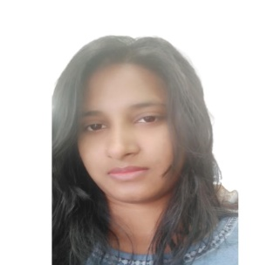 **Curriculum Vitae**

AARTI GAUR,

Contact No: 9307411067

Email id: [aarti3093gaur@gmail.com](mailto:aarti3093gaur@gmail.com)

LinkedIn: https://www.linkedin.com/in/aarti-gaur-6b7157131/

**Career Objective**

To pursue a challenging and creative career, where I can apply my existing knowledge and creativity, acquire new skills, and contribute effectively to the organization.

**Synopsis**

1. Have been good at management areas.

2. Good communication skills

**Educational Details**

GRADUATION B.Sc. (Computer Science) from Indira College of Commerce and Science (ICCS)

TY B.sc: Back lock in one Subject, drop out

SY B.sc: Pass with Second Class

FY B.sc: Pass with Second Class

H.S.C Pass with Second Grade from Maharashtra State Board.

S.S.C Pass with Second Grade from Maharashtra State Board

**Technical Knowledge:**

• Languages: C, C++, HTML, SQL (Basics), Java, PHP

• skills: Microsoft Office/MS-Excel

1. Participated in Seed IT Idol Competition in Balaji college of arts, science and commerce, pune.

2. Participated in Computer Science Poster competition in St. Mira’s College for Girls, pune.

3. Participated in Maharashtra rashtra bhasha sabha, pune.

**About Myself**

1. Hardworking and Quick learner.

2. Well adjust to changes

3. Efficient team player

**Professional Experience**

WNS Global Services Pvt. Ltd - Have 10 months experience in inbound voice process

Just Dial Limited - Have 7 months experience in inbound voice process

**Internship in Human Resource (HR)**

From Ananta Resource Management

Role : As a Internal submitter after that for 15 days done Detail Verifier role also

1. Screening the resume of the candidate
2. Sourcing the potential resume
3. Calling for Detail Verification
4. Suggesting the suitable roles for the candidates
5. Talking to the clients about their requirements
6. Used different portals like Foundit (Monster), Naukri , LinkedIn , etc.
7. Done mass mailing

**Personal Profile**

Name : Aarti Gaur

Father’s Name : Vedprakash Gaur

Permanent Address : Sr.no. 8/5/7, Sundar Colony, Kalewadi Phata, Thergaon, Pune-33.

Nationality : Indian

Date of Birth : 30-7-1992

Sex : Female

Marital Status : Single

Hobbies : Cooking, Acting, Listening music.

Languages : English, Hindi, Marathi.

Mobile no. : 9307411067

**Declaration**

I hereby declare that all the details furnished are true to best of my knowledge

Place: Pune ( Aarti gaur)

Date