**PRADEEP TYAGI**

B-704 Fortune Residency Rajnagar Extension,

Ghaziabad.

201017

E-mail: tyagipradeep98@gmail.com

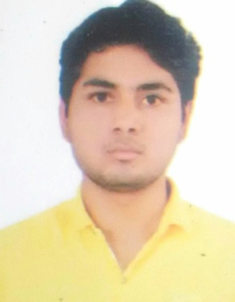Contact no: +91-9818252259

**Objective:**

Seeking an entry level position in the field of computer science and engineering where I can apply the best of my knowledge and skills with full dedication and enthusiasm to make a concrete contribution to organizational goals.

**Education:**

|  |  |  |  |
| --- | --- | --- | --- |
| **Qualification** | **University/** | **Institute** | **Year of** |
| **Board/Branch** | **Passing** |
| B. Tech. | UPTU/ | H.R. Institute of Technology | 2015 |
| Computer science |
| XIIth | CBSE | D.D.P.S | 2011 |
| Xth | CBSE | D.P.Modern Public School | 2009 |

**Work experience:**

**Organization:**  **Silver Touch Technologies Ltd.**

**Position**  **:**  **Operational Assistant.**

**Personal Details:**

**Father's Name** : MR.SHIV KUMAR TYAGI

**Date of Birth**  : 22ND march, 1994

**Hobbies and interests** : Singing, dancing, listening to music, playing cricket.

**Languages Known**  : English and Hindi.

**Nationality** : Indian

**Technical Skills:**

* Operating System : Windows 7
* Database: SQL
* Languages: C, C++, Java