**RESUME**

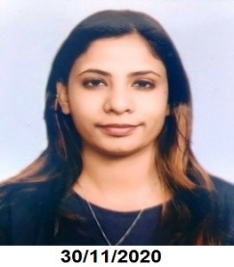

* **NIDHI**
* **Email Id:** nidhi.ennis@gmail.com
* **Mobile:** 7982450184
* **Address:** H-21 near Police Station
* Hauz Khas, New Delhi 110016.
* **CAREER OBJECTIVE**
* To begin my career at a well-liked and well-reputed institute/high school and to achieve good progress in my career through all my best knowledge and great teaching efforts.
* **EDUCATIONAL QUALIFICATION**
* Secondary Education CBSE 2011
* Senior Secondary Education CBSE 2014
* Graduation (B.A English Honours) Delhi University 2017
* Post Graduation (M.A English Honours) IGNOU 2019
* Diploma in Elementary Education Haryana Board 2021
* **EXPERIENCE**
* Working as **Assistant Manager** in AN ENTERPRISES, Lajpat Nagar
* From 1st April 2021 to 1st June 2022
* Working as **Adminstrative Assistant** in Dr Radhakrishnan International School
* Defence Colony From 4th July 2022 to 31st August 2023
* **SUMMARY/DUTIES**
* I have been doing Supervision of a Department or Team.
* Assist in making decisions related to daily operations and problem-solving.
* Handling Parents and Children also their concerns.
* Documentation: Prepare, edit and maintain documents, reports and correspondence.
* Communication: Handle phone calls, emails and other forms of communication on behalf of their supervision.
* **PERSONAL PROFILE**
* Father’s Name : Late Mr Naresh Kumar
* Date of birth : 13-03-1996
* Gender : Female
* Nationality : Indian
* Languages Known : English, Hindi & Punjabi
* Religion : Hindu
* Hobbies : Reading Books, Music , Trekking etc
* **DECLARATION**
* I hereby declare that all the abovementioned information is true to the best of my knowledge and belief.
* Place:
* Date:
* NIDHI