**Sonam Jain** 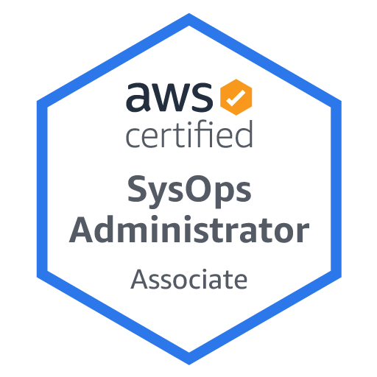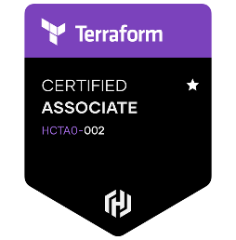

**Contact No:**7038874740

**Email :**[jsonam21@gmail.com](mailto:jsonam21@gmail.com)

**Experience Summary & Career Objective**

**~ 7.10 years** of experience as **DevOps Engineer** and **Senior Software Engineer** in Production Support . Seeking a position to utilize my skills and abilities in the industry that offers professional growth while being resourceful, innovative and flexible.

**Experience Summary**

* Experience in Devops, Release/Build Management in linux environments & expertise in automating builds and deployment process using **DevOps** tools like **Kubernetes, Docker, AWS cloud, Jenkins, Terraform, GIT, Linux, Shell scripting.**
* Good Experience in creating Kubernetes YAML manifests files & Administrator work and Good Understanding of **Kubernetes architecture**.
* Experience in **Docker Containerization**, created the **Docker images** and **containers**.
* Knowledge on writing **Docker File**.
* Experience as a Build and Release Engineer in automating, building, deploying and releasing of code in different environment using **Jenkins**.
* Knowledge on writing Jenkins code pipeline( **Jenkinsfile**).
* Knowledge on **AWS** and Experience on **Amazon EC2, S3, IAM, RDS, VPC, ECR** other services of the AWS family
* Knowledge on Installation and configuration of continuous integration tool Jenkins and Implemented **Master-Slave** concepts in Jenkins.
* Knowledge of writing **Terraform** configuration files for infrastructure provisioning and deploying it through **Jenkins** pipeline.
* End to end Change Request (CR) Estimation and Implementation.
* Managed to be an Integral part of Major Project Releases.
* Good knowledge of ITIL.
* Knowledge of UNIX ,Shell Scripting, SQL.
* Good understanding on Incident Management/Problem Management/change management.
* Providing production support to applications and maintaining the SLA.
* Identify the Root cause or troubleshooting the issue accurately.
* Good Team Player with Good Communication-Verbal, Written & Analytical skills.

**Work Experience Details**

|  |  |
| --- | --- |
| **Project 1** | Velliv, Pension &Livsforsikring A/S |
| **Company** | LTIMindtree, Pune |
| **Technical Skills** | GitHub, Terraform, Docker, Kubernetes, Git, GitHub, AWS (CloudWatch, IAM, S3, EC2) |
| **Tools** | Putty, ServiceNow, JIRA, ,Visual Studio |
| **Designation** | Senior Software Engineer |
| **Period** | 11th Jan 2021 to 09th Feb 2023. |

**Project Description:**

Velliv, Pension &Livsforsikring A/S provides life and pension insurance services. The Company offers underwriting of life insurance policies. Velliv, Pension &Livsforsikring serves customers in Denmark.It provide attractive pension solutions to more than 390,000 Danes. Policy and customer data is maintained by multiple jobs and stored in Database.

**Roles and Responsibilities :**

1. Used **Jenkins** pipelines to drive all micro services builds out to the **Docker** registry and then deployed to **Kubernetes**, created deployments and managed using Kubernetes in various environments.
2. Resolving Merge conflicts in **Git** on day-to-day basis.
3. Interacting with business team to understand the requirement.
4. Writing **Terraform** configuration files for provisioning various AWS services as and when requested by client and deployed using Jenkins pipeline.
5. Monitoring various **AWS** services through **CloudWatch**.
6. Creating CloudWatch Dashboards and alarms.

-------------------------------------------------------------------------------------------------------------------------------

|  |  |
| --- | --- |
| **Project 2** | Nordea Liv & Pension |
| **Company** | LTIMindtree, Pune |
| **Technical Skills** | Unix, Shell Scripting, MySQL |
| **Tools** | Putty, Remedy, ServiceNow, SSMS(SQL Server Management Studio), Control M |
| **Designation** | Senior Software Engineer |
| **Period** | May 2017 to 10th Jan 2021 |

**Project Description:**

Nordea Liv & Pension is a Danish Pension provider in Denmark. It is part of Nordea - the largest financial group in the Nordic countries. It Provides pension policies to lakhs of Dannes.

Policies data are maintained by multiple jobs scheduled on daily basis and stored in database.

**Roles and Responsibilities :**

1. Work on Monitoring incidents.
2. Interacting with customer and business team to resolve their issues
3. Involved in manual deployments on monthly basis to coordinate with developments team.
4. Regularly attend & resolve the issues such as application outage, Issue impacting multiple users.
5. Providing external support on release activities.
6. Adhere to escalation.
7. Scheduling the jobs using crontab command in UNIX.
8. Write UNIX scripts for automation task
9. Handling Incident, service request, problem tickets.
10. Performing daily health checks for servers.

-------------------------------------------------------------------------------------------------------------------------------------

|  |  |
| --- | --- |
| **Project 3** | Telluride( Production Support) |
| **Company** | Sears IT and Management Services (India) Pvt. Limited, Pune |
| **Technical Skills** | Unix, My SQL |
| **Tools** | Citrix, Putty, Remedy, Control M, ServiceNow, Succeed, Graphite |
| **Designation** | Technical Associate |
| **Period** | May 2015 to March 2017 |

**Project Description :**

Maintaining Millions of Member’s and Offer’s data via multiple jobs. Comparison of data between different Databases. Investigation of the Production issues and solving various Client’s queries via Quantifications

**Roles and Responsibilities :**

* Direct interaction with the client on weekly basis.
* Solving various client as well as end user’s requests that come through ticketing system, mails or calls using UNIX shell scripting/commands and SQL queries.
* Handling adhoc issues or outages proactively.
* Managing and co-ordinating various maintenance work on weekly/monthly basis.
* Handling Production issues, providing techinical support for the various client reported problems etc.

------------------------------------------------------------------------------------------------------------------------------------------

**Work Summary:**

**1st Company:**

Sears holdings India - 1st May 2015 - 23rd March 2017

**2nd Company:**

LTIMindtree - 12th May - 09th Feb 2023

**Technical Skills Summary:**

* **Technical Skills:**  UNIX, Shell Scripting, MySQL, Terraform, Amazon Web Service(Cloudwatch, IAM, S3), GitHub
* **Operating System:** Windows, Window 10, UNIX
* **Tools:** Putty, MySqlWorkbench,ServiceNow, JIRA, Remedy, SSMS(SQL Server Management Studio

**Academics Details**

|  |  |  |  |
| --- | --- | --- | --- |
| Qualification | University | Passing Year | Percentage (%) |
| B.E. (Electronics) | RGPV | 2013, June | 79.00 |

**Achievements**

* **AWS Certified SysOps Administrator - Associate (SOA-C01)**
* **HashiCorp Certified: Terraform Associate (002)**
* Got Appreciation from Business/Clients as “Star of the Month”.
* ITIL Foundation Training – 2016

**Personal Details**

|  |  |
| --- | --- |
| Name | : Sonam Jain |
| Address | : A-1206, The Address society, Wakad, Pune | |
| Date of Birth | : 21st December 1990 |
| Language | : Hindi, English |