# Priyanka M

Azure Cloud Engineer

**(+91)** 9966070345

priyanka.29m@gmail.com

To be a successful professional in globally respected company and to achieve the objectives of the company with honesty and fairness and to continuously upgrade my knowledge and skills.

# Skills

* Cloud Platform: Microsoft Azure
* Azure DevOps
* Azure IaaS & PaaS
* Networking
* Monitoring Tool- Tivoli
* ITIL- Incident, Change & Problem Management.
* ITSM Tools- Service Now
* Excellent oral and written communication skills

# Experience

## Project – 1

**Responsibilities: -**

* Experience in creating Azure cloud resources as **IaC** (Infrastructure as Code) using **Terraform**.
* Configured automation using **Ansible** (Post build activities on VMs)

### Hands-on experience on Azure Cloud Services (IaaS & PaaS), Virtual Machines, Azure Storage account, Virtual Network (VNet), Subnets, VNet Peering, Key Vault, Application gateway, Azure Policy, Recovery Service Vault, Privileged Identity Management (PIM), Azure Monitor and Azure SQL Database.

* Migrated Azure resources from one subscription/region to another using **ASR (Azure Site Recovery)**.
* Hands-on experience in **Windows VMs**.
* Using **Azure Repos** and **Azure Pipeline**, created repositories based on landscapes and building CI/CD pipelines and deploy Azure resources.
* Experience in renewal of **TLS/SSL certificates** for FQDN and uploading in Application gateway.
* Experience in **ITIL process like Incident, Change and Problem management**.
* Worked with client on regular basis to understand the requirements and ensure smooth project/task delivery.
* Designed and developed Cloud Service projects and deployed to PaaS, and IaaS.
* Experience in performing maintenance (**patching**) activities on Azure Virtual Machines.

**Project – 2**

**Responsibilities: -**

* Configuring and managing Virtual Machines using Azure portal.
* Configured Azure Virtual Networks (VNets) & subnets.
* Experience in implementation and troubleshooting Microsoft Azure Cloud services (**IaaS & PaaS**) like

### Virtual machines, Storage, Virtual Network (VNet), Subnets, Application gateway, Azure Backup.

* Performed migration of Virtual machines from one region/subscription to another.
* Configuring and monitoring Cloud services.
* Experiencing in managing existing Azure VMs and make changes whenever required.
* Enhanced existing Azure Virtual Machine images following software updates & patch releases.
* Experience in ITIL process like incident, change and problem management.
* Prioritizing the Incidents based on the impact and urgency and closing the incidents within the agreed SLA’s.
* Provided on-call support for major issues.

# Work Experience

1. Working as a Senior Analyst in **GeBBs HealthCare Solutions** from October 2019 to Till Date.
2. Worked as an Analyst/Sr Analyst in **Optum Global Solutions** from Nov 2013 to Jan 2019.

# Certifications

* Completed AZ-104 Azure Administrator Associate Certification.
* Completed AZ-900 Azure Fundamentals Certification.

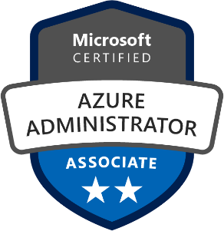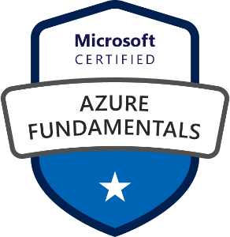

# Education

* **pursued P.G from JNTUH University in 2013**
* **pursued graduation from JNTUH University in 2011**
* **Intermediate (2005-2007)** from Board of Intermediate Education, Andhra Pradesh
* **Secondary & Higher Secondary Education. (2005)**  from Board of Secondary Education,