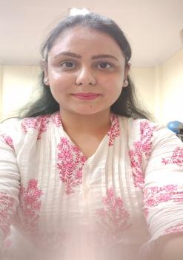

**ARANSHA KHANNA**

**OBJECTIVE**

Seek to establish a challenging career at a managerial level position in a reputed organization that would provide an exposure to synergize my Human Resource Management skills and professional expertise with its objectives.

**PERSONAL**

Date Of Birth: 07th Jul’ 1995

Father’s Name: Mr. Anurag Khanna

**EXPERIENCE**

May 2023 to till date: with Eccellente Services Pvt Ltd,

**Job Profile:** I am Senior Project lead in this organization.

Jan 2019 to till 31 May 2023: with DRDA (District Rural Development Agency)

**Job Profile:** I work as an accountant over there it was a semi government job.

July 2018 to till Jan 2019 : with MAHARISHI BHARDWAJ CONSULTANCY SERVICES

**Job Profile:** I work as a Income tax consultant and I fill Gst as well as on monthly basis.

December 2017 to July 2018 : With SRISAI CABLE NETWORKS & NEWS

**Job Profile:** Complete Independent Project Management and Co-ordination, Executing the works within time period, Preparing as well as checking the bills.

September 2017 to December 2017 With DR. Anurag Agrawal

**Job Profile:** Preparing the reports and managing the area as well as managing the machinery and all equipments.

**PROJECTS HANDLED**

**COMPANY:** Nirmal Bang securities Pvt ltd

**INDUSTRY:** Service

**PROJECT TITTLE:** Financial derivatives (future and options)

**WORK PROFILE:** 1.we work as a trainee over there and we deal with clients also but with our mentors**.**

**2.** we collect some questionnaire also which was filled by the general public of new delhi and then give it to our project mentors.

3. we do some tally calling as well as provide them some basic knowledge about our company products.

**PROFESSIONAL QUALIFICATIONS**

2017 MBA Dual Specialization in Finance and International Business.

From ABES Engineering College, Ghaziabad, 201001

2015 Bcom (Hons) in Economics and Accounting.

From IFTM University, Moradabad, 244001

**SOFTWARE SKILLS**

Worked on GST software

Worked on Income tax software

Worked on Excel

**STRENGTH**

Quick learner and Hard working as well as Smart working.

Good Communication skills

**ARANSHA KHANNA**

104/1,Deputy Ganj

Khaushlya Inter College,

Moradabad- 244001

Contact No: 6398397524

Email- aranshakhanna7@gmail.com