[Download the original attachment](https://mail.google.com/mail/?view=att&th=12ac83ef34df01b9&attid=0.1&disp=attd&realattid=f_gdirnrs4&zw)

CURRICULUM VITAE

Mita Goswami

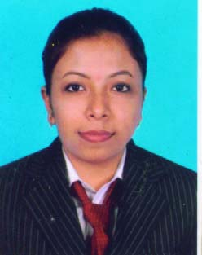

42/33 Sashi Bhusan Neogi Garden lane Kolkata – 700036

Mobile: +91 9883272483 e-mail id: [goswamimita00@gmail.com](mailto:goswamimita00@gmail.com)

**Area of Interest**

Front Office

**Educational Qualification**

Bachelor Degree In Hotel Management 2010

Passed X11 from WBCHSE 2007

**Industrial Training**

**JAIPUR PALACE**

(20 Weeks in Front Office & 02 Weeks in House Keeping department)

**Work Experience**

Join as a Team Leader in Tata AIG (From 2009 – 2011)

Join as a Front Office Executive in IInd House (A Pure Veg Boutique hotel) (From 2011 – 2015)

**Interests**

Internet surfing.

Listening Music.

**Achievement**

Won medals in drawing competition at school.

**Personal details:**

Husband Name              : Mr. Souvik Goswami

D.O.B                          :- 27th September, 1988

Languages Known      : - English, Hindi, Bengali.

Marital Status              ; - Married

Nationality                 ; Indian

Date:-   Mita Goswami

Place: -   Kolkata            Signature