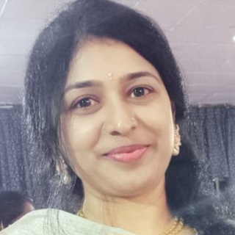

PALLEY BHAVANI

* **Phone: +91 7981 596 306**

## Email: palleybhavani@gmail.com

**Career Objective**:-

**Seeking a position as an officer that gives me pleasure to leverage organization skills to get more achievements for the company. Aiming to achieve more success in a less period with Hard-working personality traits.**

* Improve the growth of an organization.
* Develop effective communication.
* Create strategic relationships.
* Professional and business development.
* Encourage Discipline.
* Engage in team building.
* Effective Leadership qualities.

**Computer Skills**

* MS Word
* MS Excel
* MS PowerPoint
* MS Access

**ACADEMIC PROFILE**

MBA (finance) Osmania University, Hyderabad.

BCOM (General) Presidency Degree college for women Hyderabad

Class XII (commerce) HVS Girls college

Class X Stella Mary high school

**Experience**

**Oxford Grammar School**

**Worked as a Teacher.**

(Jan 2018 – Jan 2019)

**Wealus Technology Solutions Pvt Ltd.**

**Worked as HR Recruiter.**

(Feb 2019 to April 2023)

**Roles and Responsibilities**

* Human Resource planning – which I should be aware of future recruitment need & plan the strategies according to that.
* Job Design – In which I use to analysis the job & their responsibilities I should fix the pay scale of the particular job & should design the salary structure.
* Recruitment – In which I use to plan the recruiting strategy according to the position & make sure to bring the right candidate for the right position.
* On boarding – In which I use to handle smooth on boarding for new hires & make them comfortable workplace smooth orientation.
* Attendance & Leave Management – Make sure creating automatic attendance & leave management tracks & updating them on regular basis.
* Training Development – In which I use to make sure the candidates have proper on job trainings & make assessment of the candidate performance.
* Policies – In which I use to frame the policies of the company which it merges the employee work culture & make sure all the employees to keep in a disciplinary track & update them on timely basis.
* Performance Reviews – In which I have designed performance review module that integrate with company culture & make sure to happen reviews on timely basics & maintain the record to choose best employee for awards & appreciation.
* Grievance Handling – In which I use to handle the conflicts between the employees & will make a decisions to solve it.
* Event Management – In which I use to make a budget for entertainment & event expenses & I use to handle end to end of these. I use to spend amount on this according to the companies budget & strength of the company.

**Awards and Achievements**

* UNESCO Award as a best women dancer on women's ay (2021)
* Telangana world cultural organization award (2011)
* Annamacharya best dancer award (2015)
* PSTU silver jubilee award (2011)
* Shaankari dance institute best dancer award (2012)