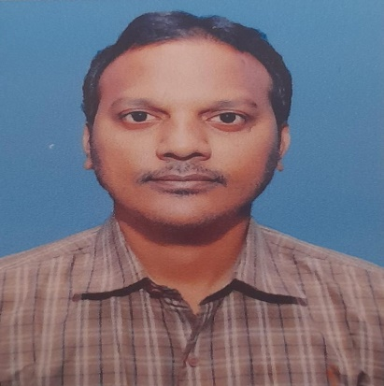

**SAMALA.BHUMESH(Deaf)**

Email Id: - [Bhumeshsamala123@gmail.com](mailto:Bhumeshsamala123@gmail.com)

**Contact No**: - 8104228014

**Career Objective:**

To start my career with an organisation where I could add value to the Organisation for the mutual success by using my technical knowledge and skills.

**EDUCATION:**

|  |  |  |  |  |
| --- | --- | --- | --- | --- |
| **Qualification** | **College/Institute** | **Board/University** | **Year** | **Aggregate** |
| **B.COM** | Madonna special Institute College  for the deaf, Vijayawada (Andhra Pradesh) | Nagarjuna  university | 2011 | 67% |
| **Intermediate** | Helen Keller special institute  College for the deaf,Hyderabad (Telangana) | Intermediate of  Board | 2008 | 58% |
| **SSC** | Little Flower school for the deaf, Warangal(Telangana) | Board of  secoundary  Education | 2006 | 72% |

**TECHNICAL SKILLS:**

➢ Typing Speed :- English Typing 35wpm

➢ Office Tools: - MS-Word, MS-Excel

**SOFT SKILLS:**

➢ Self-Motivated

➢ Ready to take up any challenge

➢ Ready work for a team

➢ Positive thinking

**PROFESSIONAL EXPERIENCE:-**

➢Company : Dharma production pvt ltd

Designation : Accountants - Exexutive

Duration : Joining on Oct 9 2019 to Till Date

Place : Andheri (Mumbai)

➢Company : Nirmal bang securities Pvt ltd

Designation : Back office

Duration : Two Year and Eight Month (2013-2015)

Place : Mumbai

➢Company : TVB Marketing Pvt Ltd

Designation : Data Entry of Operation

Duration : One Year (2011-2012)

Place : Mumbai

**HOBBIES:**

➢Cricket and Volley ball

➢ playing games

➢ Active at social media

**PERSONAL DETAILS:**

➢ DOB : February 12th 1989

➢ Gender : Male

➢ Nationality : INDIAN

➢ Languages Known : English, Indian Sign Language

➢ Marital Status : Married

➢ Address :- Room No. D/99, Mothilal Nehru Nagar S M Road, Antophill church

Mumbai, Pin code: – 400037

**DECLARATION:**

I hereby declare that the above information is true to the best of my knowledge

**Signature**

(Samala.Bhumesh)