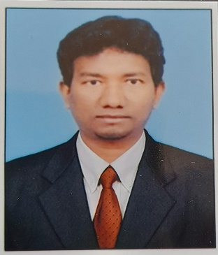

**Work Experiences** :

**Company : Northern Trust Operation Services,**

Analyst, (FA Reconciliation Team), 2017 to presently working

**Responsibilities:**

* **Performing Cash Reconciliation – Comparison of FA book and Custody books to assist FA to strike accurate NAVs.**
* **Performing stock Reconciliation-Comparison holdings of FA books.**
* **Raising queries regarding any discrepancy between FA and Custody-Corporate Action breaks, DVD and interest breaks.**
* **Verification of breaks with bloomberg for DVD rate and Interest.**
* **Commenting on the breaks as what action to be taken by FA to clear.**
* **Worked on domestic and global fund reconciliation.**
* Ensure that all income and expense payments are processed or not between GIO and Fund Master compare the diff of the transactions with available resources like BBG, FTID and Trade Tool.
* **Performing cash stock and FX Reconciliation on daily basis.**
* **Preparation of cash Reconciliation and Stock reports,**

**before and after reconciliation on client wise.**

* **Raising queries to custody regarding the breaks in cash and stock Reconciliation by using ERM Application.**
* **Raising queries to FA corporate Action when any breaks on any corporate Action events through CA SharePoint ie Team discussion.**

**Career Objective :**

A position in Finance & Accounts to utilize my skills and abilities in the company that offers professional growth while being resourceful, innovative, flexible and to contribute strongly to Organizational goal

Nagabhushana K

Contact :

✆ : +91 7259661778

✉ : Nagu1112@gmail.com

Education

* B com – IGNOU Bangalore / 2015.
* Gupta College of management and technology.
* Sree Ramakrishna Vaidya Mandir. Bangalore / 2003.

COMPUTER PRFICIENCY :

* Good in Excel. V lookup and Pivot table.
* Good knowledge on word, Excel and PowerPoint.
* Installing software.
* Hardwiring–System engineering.

Worked on different types of breaks on different types of products are as follows.

**COMPUTER PRFICIENCY :**

* Maintaining website.
* Internet, E-Mail, Outlook.
* Good knowledge on word, Excel and PowerPoint

Date :

Place : Bangalore ( Nagabhushana K )

* I am a One of the youth team member In **MARGADARSH ASSOCIATION FOR PHYSICALLY CHALLENGED (NGO).**

PERSONA DETAIL :

Permanent Address :

#367, 10h Cross, K.B colony,

Girinagar 2nd stage,

Bangalore - 560085**.**

Nationality : Indian

Marital Stats : Single

Date of Birth : 31-08-1987

Father’s name : Kadirappa N A

Languages known: English, Kannada, Telugu, Tamil, Hindi,

Interest/ Hobbies : Hand craft : Enjoying music

: Painting,

: Carom,

: Cultural activities.

Achievement: Received 2 times Start performer