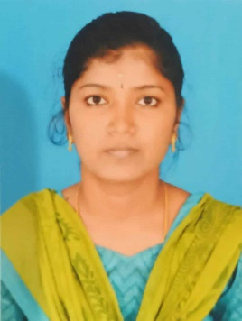**V.SARANYA**

MOBILE NO: 6369060230

EMAIL: sayanya1689@gmail.com

**CAREER OBJECTIVE**

Seeking a challenging and rewarding opportunity with an organization of repute which recognizes my true potential and effectively utilizes my excellent analytical and technical skills.

**PROFILE**

* A detail oriented, hardworking professional with exceptional programming skills possesses Master in computer application degree in Computer.
* Skilled in programming languages and using them for software developing.
* Skilled in leading the team from the front.

**PERSONAL QUALITIES**

* Smart Worker.
* Adaptability, Knowledge and Focus on work.

**TECHNICAL PROFILE**

**Operating Systems:** Windows XP, Windows 7, Windows 10.

**Programming Language:** c, c++, .Net  
**Editor and IDE:** Microsoft Visual Studio 2005, 2008 & 2010  
**Databases:** SQL Server 2000/2005/2008, MS-Access.

**ACADEMIC QUALIFICATION**

* MCA from Krishnasamy Engineering College, Anna University with 82%
* B.Sc. Bharathi arts and Science College, Thiruvalluvar University with 69%.
* HSC from Government Higher Secondary School, State Board with 60%.
* SSLC from Government Higher Secondary School, State Board with 72%.

**PROJECT DESCRIPTION**

**Title** - **“Privacy preserving VOIP using data and defense flow”**

**Software** - MS Visual Studio C#, SQL Server2005.

Description: VOIP relies on an Internet connection, your VOIP service will be affected by the quality and reliability of your broadband Internet service and sometimes by the limitations of your PC. Next we are using a peer-to-peer network setup, the peer-to-peer VoIP network consists of a core proxy network and a set of clients that connect up a VoIP route setup protocol. Then wherever you travel in the world, just as long as you have access to a high-speed Internet connection.

**EXTRA CURRICULAR ACTIVITES**

* Typewriting Higher (First class).
* Diploma in Manual Testing.
* Computer Office Automation (First Class).

**WORKING EXPERINCE**

I have 4 years’ experience in Customer Support Executive at Shopping Zone Pvt. Ltd., Chennai.

**PERSONAL PROFILE**

Name : Saranya.V

Date of birth : 16.09.1989

Nationality **:**  Indian

Languages known: English, Tamil

Hobbies : Web Surfing, Reading News Paper.

**DECLARATION**

I hereby declare that the information furnished above is true to the best of my knowledge.

Thanking you

Yours faithfully (v.saranya)