**YOGESH KUMAR MALASI**

B-8/11, Sector-19 Dwarka, New Delhi

 +91-904 783 3023

@ [malasi.yogesh@gmail.com](mailto:malasi.yogesh@gmail.com)

**EXPERIENCE**

**HIND TERMINALS PRIVATE LIMITED – Jan 2018- Present**

**Deputy Manager Administration**

* Heading complete workplace services management such as Infrastructure & facilities, Security, Vendor Management, Canteen, Telecommunications, Health Safety and environment, inventory management, and Visitor management
* Developing, reviewing and improving administrative systems, policies and procedures.
* Oversee the preparation, analysis, negotiation and review of contracts related to purchasing materials, supplies, products or services.
* Liasoning with government authorities, licenses department for smooth and seamless compliance with required statutory and legal requirements.
* Maintain and safeguard customs records.
* Organize local events, programs and other activities in company.

**Indian Army Medical Corps (Feb 1999 – Apr 2017)**

- Large practical experience in management.

- Ability to manage and lead men.

- Material handling and management to include vehicles and other resources.

- Operations

- General Administration.

- Logistics.

- Event Management.

**Academic Credentials**

|  |  |
| --- | --- |
| **Qualification** | **Institute/University** |
| Post Graduate Diploma in HR & Admin in 2019 | Tata Institute of Social Sciences (TISS) |
| Graduation certificate | Army |
| Senior secondary education | National Institute of Open School |
| Secondary Education | KV JRC Bareilly |

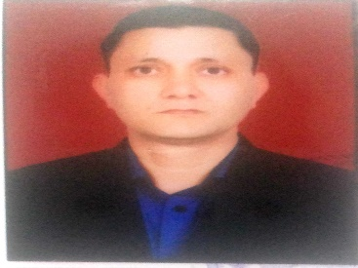

**PROFILE**

-Experience of over five years including administration, facility management, contract management, procurement, and vendor management.

- Post graduate Diploma in Human Resource & Administration

-High proficiency and working knowledge of the facility administration.

-

**KEY STRENGTHS**

Creative Solution

Adaptability

Fast learner

Effective Team Leader

**LANGUAGES**

English

Hindi

**PROFESSIONAL PROGRAMS**

* Certificate course in computer operations from NIIT- 06 months

* Diploma in office administration (Army)

* Security training certificate from Armed Forces

* Instructor Course from NCC Officers Academy, Kamptee