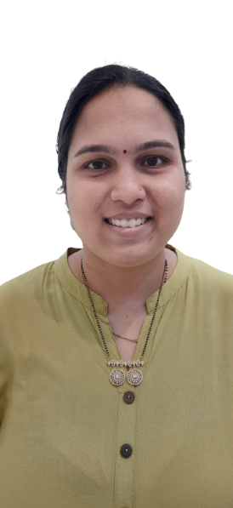Aishwarya Khade

# **Data Analyst - Scientist | Business Analyst**

Highly motivated Data Analyst with a strong background in scientific research and business analytics. Skilled in Power BI, SQL, Python, and Excel & VBA, adept at analyzing complex datasets and transforming them into actionable insights. Proven expertise in data mining, formulation, ELT integration, data modeling, and visualization. Effective communicator and a team player with a track record of delivering projects on time with accuracy.

|  |  |  |  |
| --- | --- | --- | --- |
|  | aishusk22@gmail.com |  | +91 9096603937 |
|  | Doddakannelli, Bangalore, IN |  | Linkedin.com/in/iamaishwarya |

# **SKILLS AND COMPETENCIES**

**Power BI**

**e**

**SQL**

**Tableau**

**Python**

**AL / ML**

**Excel & VBA**

**Data Mining & Scrapping**

**ELT Data Integration**

**Data Modelling**

**Data Visualization**

**MS Word**

**PowerPoint**

**Clinical Data Management**

**Assertive Communication**

**Team Player**

**Leadership**

# **WORK EXPERIENCE**

**Junior Analyst   
Sci Edge Abstract, Pune***03/2017 – Present (Remote) Bangalore, IN*

**Responsibilities:**

💡 Delivered Results: Achieved 98% accuracy and on-time delivery for tasks and projects, consistently exceeding expectations.

📈 Data Wizardry: Developed and maintained comprehensive data documentation, including insightful reports and dynamic PowerPoint presentations.

🔍 Insights Unleashed: Conducted meticulous data formulations and interpreted scientific information from research publications with precision.

📊 Data Modeling Expert: Prepared, analyzed, and verified data models for Drug Product Information (DPI), ensuring data quality control.

🔄 Seamless Integration: Implemented ELT & data integration in Software Cursory for efficient cross-referencing of related documents.

🎯 Profiling Prodigy: Performed data profiling in Inti-PALS software, uncovering valuable patterns and insights.

💬 Customer Centricity: Strengthened client relationships through clear communication and proactive assistance.

**Notable Projects:**

🏭 Drug Product Information: Led the analysis of critical pharma concepts related to drug products, contributing to data quality control.

💼 English Formulation: Translated complex scientific insights from research papers, enriching data integration efforts.

**Reference:** Ms Sayali Jadhav (Senior Data Analyst), +91-70572 – 30197

# **EDUCATION**

# **Master of Business Administration (Operations) Savitribai Phule Pune University** *06/2017 – 04/2019 GPA: 7.8/10* **Bachelor of Pharmacy Appasaheb Birnale College of Pharmacy, Sangali** *06/2012 – 04/2016 Percentage: 61.1%*

# **CERTIFICATES & TRAINING**

📜 Data Science 360 (5 month course with internship) | Analytrix Labs Bengaluru | 09/2023

📜 Become a Data Analyst | LinkedIn Learning | 10/2021

📜 Excel for Business | LinkedIn Learning | 04/2022

📜 Project Governance Fundamentals | Udemy | 03/2023

# **LANGUAGES**

|  |  |  |
| --- | --- | --- |
| **English** | **Hindi** | **Marathi** |
| *Full Professional Proficiency* | *Native or Bilingual Proficiency* | *Native or Bilingual Proficiency* |

**Personal Details**

**Date of Birth:** 22 Jun 1994

**Hobbies:** Spending time with my baby, Badminton, Travelling, Foodie