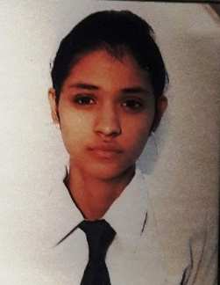**PRATISTHI**

G-2, 907, Sheen Aapt. Shalimar garden Extn-1.

Phone:-9650737109/9871641463

Email Id:-poojabhadana30.pb@gmail.com

**career objectives**

To work on a challenging job profile which provides opportunity to enhance my technical skills and knowledge, this could provide me an insight into new aspects so that it would be helpful for my career.

*education*

* Bachelor’s of Technology in Electronics & Communication from Maharishi Dayanand University, Rohtak (2012-2016) with 70%.
* Completed 12th from DAV Public School, Sahibabad, Ghaziabad with 68%.
* Completed 10th from New Adarsh Secondary Public School, Loni with 82%.

*technical profile*

Programming Software MATLAB and LABview

Operating System Window (XP)/Window7

Computer Skills MS Word, Power point, MS Excel

project work

* *summer internship*

|  |  |
| --- | --- |
| Title | Fire Escape Robo |
| Organisation | Centre for Fire Explosion and Environment Safety, Timarpur, Delhi Lab of DRDO Ministry of Defence. |
| Tenure | Two month |
| Objective | To alert from fire damage |
| Project Description | The project deals with a security alarm which operate after sensing high temperature in surrounding. |

* *SEMESTER INTERNSHIP*

|  |  |
| --- | --- |
| Title | Interfacing of Lock-in Amplifier in MATLAB & its Signal Conditioning |
| Organisation | Defence Research & Development Organisation, Delhi. |
| Tenure | Six month |
| Objective | To Interface Lock-In Amplifier with MATLAB. |
| Project Description | The project deals with interfacing of device with MATLAB by USB &It’s Signal conditioning. |

EXPERIENCE

|  |  |
| --- | --- |
| organisation | vayam info solution pvt ltd |
| Designation | Tsg Engineer |
| site | bharti (AIRTEL) |
| DURATION | 1 year |
| location | noida |

*personal profile*

Name Pratisthi

Date of Birth 30th May 1995

Gender Female

Language known English, Hindi

Permanent Address 907/G-2, Sheen Appt, Shalimar Garden Extn-1, Ghaziabad

*declaration*

I hereby declare that above furnished particulars are true to the best of my knowledge and belief.

Place: Pratisthi

Date: