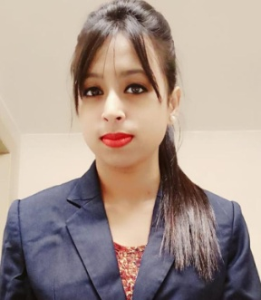

# CONTACT INFORMATION

CONTACT: 7003396525

**MAIL**: rupshadas56@gmail.com

**ADDRESS:** 521/b, dumdum park, Kolkata.

**PERSONAL INFORMATION**

**Date of Birth:** February 4, 1997

**Citizenship:** Indian

**Gender:** Female

**Civil Status:** Single

**Language:** English, Bengali, and Hindi.

# CORE QUALIFICATIONS

* Proficient in Microsoft windows, and other internet applications.
* Proficient in ms word, excel and PowerPoint.
* Above average and effective communication skills.

**RUPSHA DAS**

**CAREER OBJECTIVES**

*-To work with the advanced and progressive schools where knowledge,*

*skills and abilities can be contributed towards students.*

*-To utilize different learning opportunities for the students*

*-To practice teaching through virtual field experience.*

**EDUCATIONAL ATTAINMENT**

* Class 10th, Auxilium convent school, year – 2013, percentage – 65%
* Class 12th, Auxilium convent school, year – 2015, percentage – 82%
* B.A HISTORY, SCOTTISH CHURCH COLLEGE, passing year-2018 percentage –54%
* M.A HISTORY, UNIVERSITY OF CALCUTTA, passing year –2020 percentage – 53.4%
* B.Ed, ADAMAS UNIVERSITY, YEAR – PURSUING.

**PROFILE AND OTHER SKILLS**

# Dedicated and hard working individual.

# Ability to adapt to changes.

# Can work properly and effectively under time pressure.

# Has the ability to cooperate with others effectively.

# Has the ability to work with minimal supervision.

# Has the quality of a good listener.

# Good communication skills.

* Good moral character and behavior.

# CHARACTER REFERENCES

**Dr. PragyanMohanty**

Assistant Professor, School of Education, Adamas University

pragyan.mohanty@adamasuniversity.ac.in

**Mr. Pranay Pandey**

Assistant Professor, School of Education, Adamas University

[pranay.pandey@adamasuniversity.ac.in](mailto:pranay.pandey@adamasuniversity.ac.in)

**Dr. Soma Das Mondal**

Assistant Professor, School of Education, Adamas University

somadas.mondal@adamasuniversity.ac.in

# AUTHENTICITY STATEMENT

*I hear by certify that this CV has been accomplished by me and is true and correct to the best of my knowledge and belief.*

***RUPSHA DAS***

*APPLICANT*