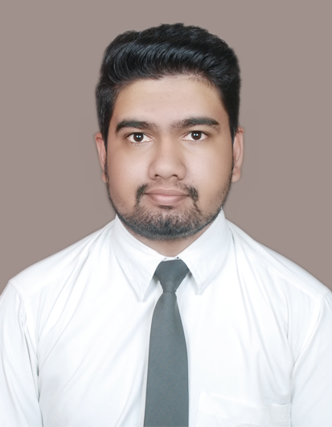

**DHEERAJ CHINAGI**

E-mail:dheeruchinagi@gmail.com

Mobile: 8050868895

LinkedIn: [www.linkedin.com/in/dheeraj-chinagi-182b4a86](http://www.linkedin.com/in/dheeraj-chinagi-182b4a86)

**_______________________________________________________________________________________**

**CAREER OBJECTIVE:**

To work for an organization which provides me the opportunity to improve my skills and knowledge to growth along with the organization.

**EDUCATIONAL QUALIFICATIONS:**

|  |  |  |  |
| --- | --- | --- | --- |
| **COURSE** | **SCHOOL/COLLEGE** | **YEAR OF PASSING** | **PERCENTAGE** |
| MBA  (Marketing & HR) | M.S. RAMAIAH MANAGEMENT INSTITUTE, BANGALORE | 2017 | 61% |
| BBA  (Marketing) | B.L.D.E.A  A.S.PATIL  COLLEGE OF COMMERCE, BIJAPUR | 2015 | 74% |
| Class 12th | V.B.DARBAR PU COLLEGE, BIJAPUR | 2012 | 44% |
| Class 10th | V.B.DARBAR HIGHER SEC.SCHOOL, BIJAPUR | 2010 | 67% |

**PROJECTS UNDERTAKEN:**

**1. POST GRADUATION:**

**1(A). SUMMER INTERNSHIP PROJECT:**

|  |  |
| --- | --- |
| **TITLE** | Study of retailer’s satisfaction towards the products of Flowserve Microfinish valves Pvt. Ltd |
| **DESCRIPTION** | * This project is to understand the retailer’s perception towards the products of Flowserve Microfinish valves Pvt. Ltd * Conducted a market analysis for Flowserve Microfinish valves Pvt. Ltd to build the database * The research to understand retailers satisfaction in the Hubli |

|  |  |
| --- | --- |
| TITLE | Relationship marketing in banking with reference to private banks |
| DESCRIPTION | Project is to understand the importance of relationship marketing in private banks of BangaloreTo know the relevance of relationship marketing in banking industryTo assess whether or not relationship marketing leads to customer satisfaction |

## 1(B). EMPIRICAL STUDY:

## 2. UNDER GRADUATION:

|  |  |
| --- | --- |
| **TITLE** | A. Organization study on customer satisfaction of A.V.S Ayurveda Mahavidyalaya hospital, Bijapur.  B. A Study Report on Organizational Study at Pacific beverages, Bijapur. |

**SAP BASIC IMPLEMENTATION AND END USER:**

Under took SAP Training in MATERIAL MANAGEMENT Module from GIT IT Academy, Hubli

Proficient areas:

Definition and Corresponding Assignments.

* Company Code.
* Plant Code.
* Purchase Organization & Assignment to Ref Purchasing Org.
* Defining Warehouse number.

Creation:

* MRP Controllers, Payment terms.
* Purchase Groups, Storage location and address.

Working with Masters:

* Material Master. (Creation, Change, Delete, Display) & knowledge of different Views.
* Vendor Master. (Creation, Change, Display)
* Excise Master. (Creation, Change, Delete, Display) & knowledge of Chapter ID.
* Source List. (Creation, Change, Delete, Display)

Applications:

* Understanding of flowchart of SAP MM.
* Using Mass Maintenance for Material Master (MM17)
* Creation, Change Display of Purchase Requisition.
* Creation, Change Display of Purchase Order.
* Consolidating data and export to excel through Standard Tcodes. (MB51, ME2N, ME2M etc.)
* Data Extraction from SAP tables through Tcode SE16N /SE11.

**STRENGTHS:**

* Self-motivated
* Ability to work in a team
* Keen to work hard
* Bear pressure and work under stress

**TECHNICAL COMPETENCIES:**

* SAP R/3(ECC 6.0) MM
* TALLY ERP 9
* MICROSOFT OFFICE (EXCEL, WORD, POWERPOINT)
* SPSS

**HOBBIES AND INTERESTS:**

Playing chess, travelling and listening to music.

**PERSONAL PROFILE:**

**Father’s Name :** RAJENDRA CHINAGI

**Mother’s Name :** ARUNA CHINAGI

**Date of Birth :** 01st May 1994

**Languages Known :** English, Hindi, Kannada, and Marathi

**Permanent Address :** Indi road, Rajput Galli, Bijapur-586101