## RESUME

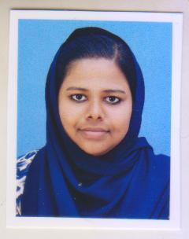**ASHIDHA P A**

PAROOL ANAPPAN VEEDU

POOMANGALAM

PANNIYOOR P. O.

(VAI) KARIMBAM

KANNUR DT. PIN: 670142

Mob: 8606742762

*E-mail: ashidhapa3@gmail.com*

# CAREER OBJECTIVE

### ***Secure a responsible career opportunity to fully utilize my training and skills, while making a significant contribution to the success of the company .***

# EDUCATIONAL QUALIFICATIONS

**DEGREE - BSc.Physics** at Taliparamba Arts & Science College,

Taliparamba.

**VIBES - (diploma in virtual interactive business experiment system).**

Under Bharathiyar university**.**

**Plus Two** - **GHSS KOTILA**, Board of Higher Secondary Examination, Kerala ,

**SSLC - SEETHI SAHIB HSS**, Board of Public Examination, Kerala

# WORK EXPERIENCE & ADITIONAL QUALIFICATION

2 + YEARS OF EXPERIENCE IN ACCOUNTANT AND BILLING SECTION.

* TALLY . ERP9
* PEACHTREE
* QUICK BOOKS
* TRADEASY

AND ALSO SPECIALIZED IN

* RETAIL TRADING
* MANUFACTURING
* PAYROLL

# SKILLS

* PYTHON
* VISUAL BASIC
* C PROGRAMMING
* DATA BASE

# PERSONAL INFORMATION

Father’s Name : : HATHIM P

Full name : **ASHIDHA P A**

Date of Birth : 01/09/1997

Gender : Female

Nationality : Indian

Marital Status : Un Married

Religion : Muslim

Languages Known : English, Malayalam, Urdu and Hindi

# STRENGTH

* HARDWORKING
* POSITIVE MINDED
* STORNG WILLPOWER
* CONFLICT MANAGEMENT

# HOBBIES

* READING BOOKS & NEWS PAPER
* WRITING

# **DECLARATION**

***I hereby declare that the above mentioned information is correct to the best of my knowledge and belief****.*

Place: Poomangalam

Date:

**ASHIDHA P A**