**CURRICULUM VITAE**

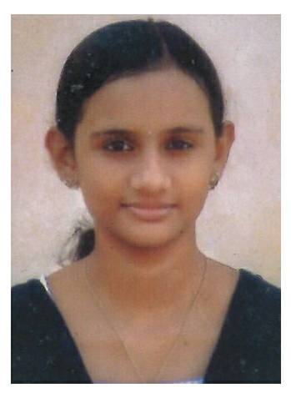

**SILPA K PREM**

**Karimalipuzha house**

**Pampavalley P.O**

**Erumely Email:** [**silpakprem.sp@gmail.com**](mailto:silpakprem.sp@gmail.com) **Kottayam (dist) Mobile: 9946387316**

**Pin: 686510**

**Kerala.**

|  |
| --- |
| **PERSONAL INFORMATION** |

|  |
| --- |
| **Career Objective:-** |

Seeking a responsible job, where my knowledge and skills can be utilized and use it as an opportunity to work for social benefit and company’s growth. To shoulder independent, challenging and rewarding career in a professionally managed .progressive corporate where significant contribution through concrete achievement results in personal growth

|  |
| --- |
| **Personal Qualities:-** |

I have quality of maintaining good interpersonal relationship with other personals sincere and dedication to my profession and I am punctual and systematic at work.

|  |
| --- |
| **Academic Qualification:-** |

|  |  |  |  |  |
| --- | --- | --- | --- | --- |
| **Qualification** | **Board/ University** | **Institution** | **%of marks** | **Year of Passing** |
| B.com | M G University | MES College , Erumely | 71 | 2016 |
| 12 | CBSE | Jawahar Navodaya Vidyalaya,Pathanamthitta | 62 | 2013 |
| 10 | CBSE | Jawahar Navodaya Vidyalaya,Pathanamthitta | 96 | 2011 |
|  |  |  |  |  |

|  |
| --- |
| **Certification Courses:-** |

* Tally ERP 9
* System Analysis and Programming (SAP Fico & SAP B1).
* Peach Tree

|  |
| --- |
| **Strengths:-** |

* Communicating skills
* Flexibility and adaptability
* Strong work ethic
* Honesty and integrity
* Accuracy

|  |
| --- |
| **Skills** |

* MS Word
* MS Office
* Quickbooks

|  |
| --- |
| **Personal Details:-** |

Date of Birth : 10/06/1995

Gender : Female

Father’s Name : K M Premkrupal

Marital Status : Single

Nationality : Indian

Religion : Hindu

Languages Known : English, Malayalam

|  |
| --- |
| **Declaration:-** |

I hereby declare that all the information and facts given above are true to best of my knowledge and that I am in possession of the documents in proof to the claim made in this resume.

Place: Erumely

Date: 02-06-2017 Silpa K Prem