**Curriculum vitae**

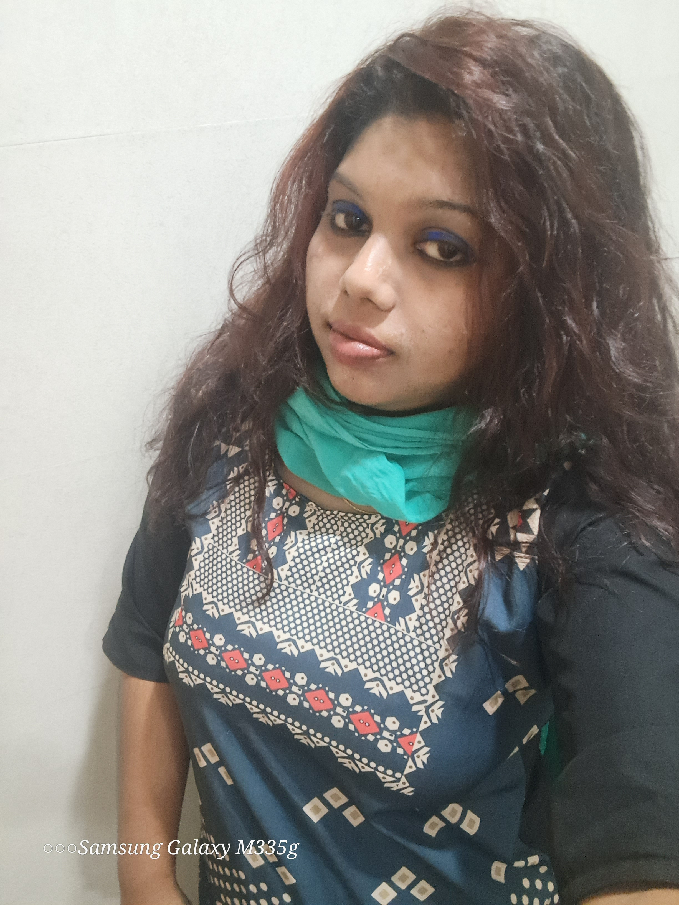

**J. Nancy Narmada**

**Date Of Birth : 19-02-1990**

**Mob: 9884370133/ 9840722934**

**Mail: nancynarmadha@gmail.com**

**Languages Known : Tamil And English**

**Martial Status: Single**

**Career Objective:**

**I am hoping to acquire a challenging human resource management position where I make use of my extensive experience in the field to handle staff recruitment and promote employee relations to increase the overall effectiveness of the company workforce.**

**Education:**

**2005**

**Chennai, India: SSLC, St. Theresa Girls Higher Sec. School**

**2007**

**Chennai, India: HSC [Economics/Accountancy/Business Math’s],**

**St. Theresa Girls Higher Sec. School**

**2007 – 2010**

**Chennai, India: BBA, Vel's College of Arts and Science**

**2010 – 2012**

**Chennai, India: MBA - Human Resources, University of Madras**

**Professional Experience:**

**July 2012 – July 2013**

**Chennai, India Tele Caller, Citi Bank**

**Leveraged CRM database to manage customer data, log calls and other activities and generate reporting to deliver actionable insights and develop sales pipeline.**

**Completed daily cold calling and outreach to build sales pipeline.**

**Recorded contact information of customers and potential customers in internal database.**

**Answered inbound telephone calls from interested customers to persuasively discuss offerings.**

**Set up appointments with interested customers according to schedule availability.**

**Delivered prepared sales pitch from script and persuaded potential customer to purchase the product.**

**September 2013 – September 2014**

**Chennai, India Human Resource, Wiseman Consultancy**

**Pre-screened resumes prior to sending to corporate hiring managers for consideration.**

**Recruited, hired and oversaw staff by overseeing job interviews, conducting exit interviews and leading on boarding sessions.**

**Coordinated employee placements and administration.**

**October 2014 – December 2016 Chennai, India Customer Support Executive, Book my Show (BIG TREE ENTERTAINMENT PVT LTD)**

**Established and monitored customer service standards by employing recognized and comprehensive benchmarks.**

**Provided excellent customer service by efficiently resolving issues and responding to inquiries**

**Resolved issues through active listening and open-ended questioning, escalating major problems to manager.**

**Maintained consistent communication with leadership team to manage customer service effectiveness by monitoring performance and assessing metrics.**

**February 2017 – March 2018**

**Chennai, India Front office Executive & Admin, Manpower Construction& Builders**

**Answered, responded to and transferred over daily phone calls on multi-line phone system.**

**Coordinated office activities and operations, secured compliance to company policies and welcomed, screened and routed guests.**

**Actively listened to customers, handled concerns quickly and escalated major issues to supervisor.**

**November 2018 – May 2023**

**Chennai, India Front office Executive & HR Admin, Tag Corporation**

**Coordinated office activities and operations, secured compliance to company policies and welcomed, screened and routed guests.**

**Answered, responded to and transferred over daily phone calls on multi-line phone system.**

**Coordinated work activities for HR managers, specialists and recruiting agents.**

**Maintained optimal staffing levels by tracking vacancies and initiating recruitment and interview processes to identify qualified candidates.**

**Projects:**

**Customer Satisfaction study on Home Loan in ICICI Bank, PROJECT (UG)**

**A feasibility study on Customers satisfaction in Home Loan about the loan process, Rate of Interest and Customer retreat in ICICI BANK.**

**Incentive Scheme Process for workers in Fatima Shoes Pvt Ltd, PROJECT (PG)**

**A study about the incentive scheme for the workers in the Fatima Shoes Pvt Ltd.**

**Computer Skills:**

**Basic working knowledge in MS-Office and MS –Excel**

**Typing Skills :**

* **Ms Word**
* **Ms Excel**

**DATE:**

**PLACE:**

**J. NANCY NARMADHA**