**RESUME**

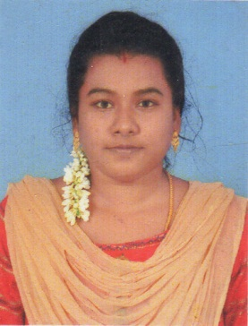

**M.ARUL UMA**

W/o Sprencher

3/1823 South Street Akkalmadam

Pamban. Rameshwaram E-Mail id : [mosesaruluma@gmail.com](mailto:mosesaruluma@gmail.com) Mobile No: 80157 40582

**CARRIER OBJECTIVE**

To work in an organization where my skills and competence can be utilized and to constantly update my knowledge, thereby leading to rapid growth along with the organization.

**EDUCATIONAL QUALIFICATION**

|  |  |  |  |  |
| --- | --- | --- | --- | --- |
| **Degree/SchooLIng** | **NAME OF THE INSTITUTION** | **BOARD/**  **UNIVERSITY** | **Academic year** | **%** |
| MSc | Syedammal Arts and Science College  Ramanathapuram | Alagappa  University | 2021-2023 | 70 |
| B.ed., | Sastha College  Karaikudi | Teachers Educational University | 2017-2019 | 82 |
| Bsc(Computer science) | Matha College of Arts and Science,  Manamadurai. | Alagappa  University | 2012-2015 | 77 |
| HSC | St.Joseph’s Higher Secondary School,  Rameswram. | State Board | 2011-2012 | 72.58 |
| SSLC | St.Joseph Higher Secondary School,  Rameswaram. | State Board | 2009-2010 | 72.8 |

## FIELDS OF INTEREST

* Programming.
* Multimedia.
* Web Designing.
* Computer Networks.

## PROFESSIONAL SKILLS

* Language : C, JAVA,HTML, .NET,
* Application Software’s : Photoshop.

## PROJECT DETAILS

* Online exam Question Model

**EXTRA CO-CURRICULAR ACTIVITIES & HOBBIES**

.

* Reading news paper
* Reading books.

**PERSONAL DETAILS**

Date of Birth : 24.02.1995

Gender : Female

Marital status : Married

Religion : Christian

Languages Known : English, Tamil

Working exprence : 1year online work in net center

Permanent Addres : W/o Sprencher

3/1823 South Street,

Akkalmadam,

Pamban - 623521

Ramanathapuram(DT).

**DECLARATION.** I hereby declare that all the information furnished above is true to the best of my Knowledge and belief.

Place:

Date: Yours Truly,

(M.ARULUMA)