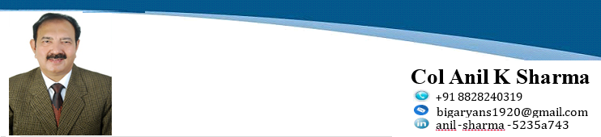



A dynamic and charismatic leader with logical and innovative thinking. A great strategist and executer with Midas touch to turn dreams into realities. A nation builder and true organizational man with proven record of 33 years in the INDIAN ARMY (INFANTRY – the main fighting arm, Queen of Battle, the ultimate), a War veteran of **many Battles** and insurgencies viz. **Kargil, J&K, Punjab, Assam, Manipur**. An alumni of Indian Institute of Management (IIM) Lucknow. 33 years exceptional experience of Strategic Leadership, Strategic Management, Administration, HR functions( Recruitment, Learning & Development, Staffing, Pay, Pensions) ,Head Security, Project & Operational Management, Work Studies, Logistics & Supply Chain Management, Estate Management -headed establishments over 15000 personnel and multi Billion Rupees worth high-tech equipment. Highly motivated, creative, visionary, pro-active manager with abilities to set high standards and ensure accomplishment of goals by energetic, effective & assertive leadership, motivation, adept and coordinated team efforts. I feel confident that my experience will enable me to add value to any assignment and steer the institution to new heights of excellence

|  |
| --- |
|  |
| Strategic,Leadership& Management |

**PROFESSIONAL EXPERIENCES**

**Human Resource Management ( HRM) .** Highly experienced in **E2E HR functions/process from R2R (recruitment to retirement) of Army personnel.**

* **Talent Acquisition and Recruitment ( Zonal Recruitment Office at Zonal Level Jammu).**Selected many boys into Army as Soldiers on daily basis. A very lengthy process which involved :
* Advertisements in papers, calling for Applications, authenticating education credentials from State Boards of Education/ Districts HQs/Police Verifications.
* Sending Call Letters for Physical & Written Tests
* Screening of Applicants and Conducting Physical tests & written Examinations.
* Marking Papers and declaring results. Medical Fitness Examinations.
* Compiling Merit Lists and declaring final results
* Forwarding joining letters to selected candidates to join Training at Training Centres –different centres for different Arms – Infantry, Armour, Arty
* **Head HR -Recruitment & Training Officer At Jabalpur Training Centre.** A training Centre, is the home of Soldiers from his recruitment to retirement. All basic HR functions of recruitment , selection, training (L&D), Performance Management, compensation & benefits, Rewards & Awards, Promotions, HRIS (records maintenance, succession planning, preparation of PPOs( pension Payment Orders) for JCO ( Junior Commissioned Officers) & Soldiers are carried out there. Got in depth knowledge of all these HR functions there
* **Recruitments**.Recruited, trained, transformed more than **10000 village** boys into fight fit soldiers & coordinated activities of talent acquisition, recruitment, training, staffing, hiring, grooming & transforming

|  |
| --- |
| Soft Skills |
| Interpersonal Team  Relationship Building    Excellent Effective  Motivator Communicator |
|  |

* **Training.** Trained more than 10000 newly recruits into fighting fit soldiers in 09 months training periods of different batches in all weapons ( Small Arms – Rifles, Carbines, Light Machine Guns, Medium Machine Guns, Heavy Machine Guns, Mortars, Rocket Launchers, Grenade Firing, Mine Laying & demolition Training, Physical Training with different loads**, setting up of army Camps,** Leadership & Motivation, Behavioral Sciences, Team Leadership, Inter-personal skills, Group Tasks, Map Reading, Army Law. Many of my trained boys won medals at international events in Firing & sports. Sub Sanjay Kumar PVC ( Param Vir Chakra – Kargil War) was recruited & trained by me.
* **Professional Competitions.** As a Team Leader, my teams under me won many professional Competitions at Division/CORPS levels, of Small Arms Firing competition ( Pistol, LMG, Rifle), Rocket Launchers, Mine Laying Competition- was adjudged best Officer in Charge in SA Fire & Mine Laying Competitions many times, best innovations and my innovations were circulated throughout Northern Command, later into Army Courses of instructions. Though being an Infantry Officer, I was the sole authority in planning & Coordinating of Live Minefields along J& K border, carried out various trials in Mine Laying in Punjab Firozpur Area
* **Discipline, Feedback & Redressals**. Being highly disciplined myself, believer & achiever, set & maintained high standards of Discipline by personal example of leading from front in battles & insurgencies. No let ups in professional matters. Always Focused on Goal settings & enhancing **employee satisfaction** by implementing various employee welfare schemes and resolving grievances by prompt & positive feedbacks.
* **Appraisals, Postings and Promotions**. Maintained records of ACRs ( Annual Confidential Reports) **of 21 Units (17850 JCOs & soldiers)**, carried out their Postings and Promotions based on their Appraisals.
* **Pensioner/Retirement Benefits. Every Month,helped 200-250 (3000) per Year,** **Jcos & Soldiers** proceeding on Pension/retirement in preparation of PPOs( Pension Payment Orders) & final settlement of their - **Pensionary benefits/ AGIF- Army Group Insurance Funds**, **Gratuity**) with Controller Defence Audit Office(CDA) before they finally hung their Uniforms.
* **Veer Naris/ War Widows.** Helped War Widows of Martyred Soldiers in getting their Dues ( Pension, Awards, other benefits from Govt).
* **Punishments and Awards.** Provided legal advice on punishments and shortlisted Soldiers for Awards based on their performances. **Formulated new policies for selection process for awards.**
* **Recruitment through Open Rallies. R**ecruited many Soldiers through open rallies, procedures are same but Strength of boys joining Army goes up to 100,000 per day. Herculean task to manage such numbers and to carry out Tests in front of open Public.
* **Campus Interviews.** Under University entry scheme (UES),Conducted campus interviews for III & IV year Engg Students of Engg Colleges at Jabalpur,Raipur,Bhilai(Durg),Rewa, as Technical Officers in Army.

* **Head HR – Education ,Sports & Training officer 2015-17 at Mumbai**.
* Headed Education & promotional exams all Officers & Soldiers (nos in Lacs) of all Units of North Maharashtra- Mumbai, Deolali, Nashik, Kampti, Bhusawal & entire Gujarat State (Baroda, Ahmedabad, Bhuj, Ahmednagar, Rajkot, Jamnagar, Surat), reporting directly to me ,focusing on key areas of Education, Training, Sports and Administration.
* Managed the functioning & administration of Army Public Schools at Various locations in Army. Under my guidance, APS Sukna was declared **2nd best APS** throughout India, on the basis of merit and marks obtained by students though being located at a remotest place next to Mahananda Wildlife sanctuary with very meagre available resources.
* Pioneer in introducing the concept of **e-learning** at APS Sri Ganga Nagar, first among all APS of India in 2007.
* Selection of Principal and Teachers of APS.
* Conducted many JEE, AIIMS, AFMC, MBA exams at various stations in India.
* Selected and Trained many Sports Teams for various National/International Competitions.
* Organized Summer camps for children from 6-20 years age and trained them in different Sports.

**Carrier Guidance.** Guided, Motivated & Helped my subordinates / junior & middle level executives in qualifying various competitive Examinations (Combined Defence Services /Banking/State Civil Services exams) thus helped them to rise in higher echelons.

* **Outsourcing of Manpower**
* **Pioneer in Indian Army in Outsourcing of Manpower for Conservancy services at Sukna Military Station, the recruitment**  was banned since 1984, thus gave employability to many Local boys. This Model was later replicated & introduced in all Military Stations of India. This Manpower planning was a herculean task which involved total numbers of houses, officers/JCOs &Soldiers families, single soldiers livings in Unit lines, total acreages of Military Station, total numbers with length & bredth of Roads, Culverts, tracks, Drainages, Shopping centers, Schools, Auditoriums, Offices, Playing Grounds, then working out Manpower deficiencies, Provisioning & Budgeting, obtaining sanction from Army HQs through Chain Of Commands, Budget Approval from AHQ, Advertising, sending of RFPs, selection of Lowest bidders for provisioning of Outsourced Manpower, their daily employability, attendances, absentees, Payments ,Risk & rewards, Audits.
* **Legal/ Discipline**
* Having qualified in Military Law - Conducted many Court of Enquiries & Summary Of Evidences
* Conducted/Attended Court Martial Proceedings (which is equivalent to Session Courts in Civil) of many Officers & Soldiers.
* **Head HR & Facilities Management 2011-14 at Mumbai**. In 2011,after Kasab attack at CST( Chatarpati Shiva JI) Railway Station, **handpicked by Army and posted at CST**, to assist Railways on Security matters. Identified & renovated many Army/Navy Railway Platforms lying in dilapidated state .Inspected & improved security of Railway Stations.
* Managed the Movements of Officers & Soldiers of all three services ( Army, Navy, Air Force & Coastal Guards) and Ammunition & Armaments, Heavy Equipment & Stores, Tanks, Guns, movements of Special Army Trains from Mumbai to all parts of India including NDA( National Defense Academy) Special, Maintenance & upkeep of Rolling Staff in ready position throughout the year at different Railway Stations throughout India.

**Estate Manager/ Administrative Commandant & Security Head of a Military Station Sukna 2008-11** . Was solely responsible for Planning & forecasting layout of entire Cantonment infrastructure, new developments including Creating of new assets, buildings, infrastructures, total Logistic support( Transport, accommodation, Ration, welfare, medical) for a total of 20000 officers, JCOs soldiers & their families, yearly maintenance & repair works of buildings/roads/ culverts,-health & hygiene ,upkeep of Station, Land Custodian of 5000 acres entire military station.

* **Project Management**. Carried out Structural Audit of Old Buildings, Worked out demands for newly Constructed & renovated Married Accommodation Projects of 924 Officers and 3056 houses for Junior Commissioned Officers & Soldiers including Servant Quarters, Garages, Parks, Roads, Go- Karting, Paly grounds , Officers Messes, Unit Lines, Cook Houses, Auditoriums, Banks, amounting to Billions of Rupees. Concepts Conceived, Demands worked out, Planned & Executed in Flawless & Time Bound Manner thus adhering to TQM ( Total Quality Management). **Forecasting & budgeting of New & Old Projects including Five years Roll Over Plans.**
* **Test Audits.** Got done, yearly & Five yearly Test Audits of all Projects, Revenue & expenditures of all projects & Funds under various heads( ACGs, Public, ECGs, Major, Minor Works etc) by dedicated teams by Govt of India. Received appreciation from them and Sukna Mil Station was declared best Mil Station among all stations of India, with NO OBSERVATIONS.
* Provisioning of water & electricity Supply to entire Station from W. Bengal Govt.
* **Land Officer. As Administrative Commandant,** Was the sole custodian of entire Mil Station land of 5000 acres ,responsibilities included provisioning, requisition & acquisitions ,hiring/de-hiring and Maintenance of entire Defense Land.
* **Maintained security/discipline of entire Station.**
* **Removed Encroachments**. This Mil Station is located in the so called claimed Gorkha Land in Darjeeling Hills in W. Bengal. A large chunk - 2548 Acres of Defense Land was encroached by GNLF leader Mr Subash Ghising, who founded GNLF (Gorkha National Liberation Front) &was demanding a separate Gorkhaland state .Records of our land were burnt by local Revenue (Tehsildar) & DEO( our own Defence estate Officer – Darjeeling). I unearthed the records by liaison with Local public, I was even threatened with dire consequences. Not withstanding that, I removed their encroachment with help from Local Administration & Police thus saved Billions worth over **INR 3000 Crores** of Army/ Govt.
* **Stopped Illegal Land Mining & Querying of Stones** from Rivers & Nalas(Rivulets) of that area.

## PROJECT STUDIES

## Civil .

* **Work Study. In 1992,** Conducted **work study at Dumdum Airport**  Calcutta to minimize losses (in Billions) suffered by airport and forecasted Air Traffic from Kolkata for next 30 years till 2022 (Domestic as well as International), formulated SOPs in Streamlining daily functioning and smooth administration of Airport.
* **Manpower and Transport planning of Airport. F**orecasted and calculated Manpower and transport by using various Models & techniques like **Time & Motion, CB , SWOT Analysis, Six Sigma, Porter’s Five Forces, Critical Path method** – **cargo, space utilization, fire protection, landscaping, overall security & outsourcing of various airport services.**
* **Our recommendations were not only**  appreciated but implemented in Toto by Chairman Airport Authority of India at New Delhi.
* **Saved Army Land at Mumbai (2014 -17), dealt with Civil & Govt agencies** in resolution of **Army Land issues** of entire North Maharashtra- Mumbai, Deolali, Nashik, Bhusaval, Nagpur and entire Gujarat state Military stations of Baroda, Bhuj, Ahmedabad, Jamnagar, Surat, Rajkot.
* Formulated Zonal plans for all Military Stations.
* **Unearthed 300 acres ( Worth – invaluable in multi billions) of Army A-1 defense land from MHADA at Santa Cruz and saved Army Land at Malad. Same with other stations of Gujarat & Maharashtra.**
* I retired from Mumbai (Colaba) as Chief Land , Security, Education & Training Officer.
* **Renovation of Army Platforms & Railway Lines at Mumbai.** When I joined, 09 Army, Navy & Air Force ARFs ( Additional Rail Facilities) – Platforms along with leading railway lines were lying in dilapidated state with no maintenance what so ever and were recommended to be surrendered to Railways. With vast experiences of Administration/HR/Land matters behind me, I took this Herculean Project of renovation & restoration of these Railway facilities. It involved dealing & convincing Officers with long Chains of hierarchical Commands of FOUR DIFFERENT GOVT ORGANISATIONS ( Army, Navy, Airforce & Railways). I made presentations at our Army Head quarters New Delhi, Naval & Air Force HQs and Railways DRMs/ Commercial & General Managers. While digging deep, came to know, this land did not belong to Railways but to MBT ( Mumbai Port Trust). With my relentless efforts, I got orders reversed from all HQs and got them repaired/renovated and Functional, A rare feat to achieve within a stipulated period of 02 years of my tenure after taking over my command, which involved convincing, cancellation of orders, projecting renovation/repair estimations/works, budgeting by Railways, Tender action, selection of vendors, finally execution of work by third Party Railways on Ground.
* **Recommended a New Alternate Railway Line connecting Wadala to Kurla for Army/Goods Trains if Dadar Station gets Choked off . Happy to know that, the work has started now.**
* **Plantation of Tress in Rajasthan**. With the help of Local population, planted various varieties of local surviving Trees like, Neem, Philahi, Sheesham, Mangoes, Peepal in Churu distt of Rajasthan to conserve water & to save this planet from depleting Ozone layer. It helped in cloud formation & rains.
* **Human Rights Seminars**. Coordinated & Conducted HR Seminars at Jammu during peak of Militancy, to educate people on Human rights, with Chief panelist former CJI ( chief Justice of india) Sh J S Verma, Sh Arun Shourie( then cabinet Minister I&B), Dr Farookh Abdullah, CM of J&K , Sh. Girish Saxena- Governor J&K, entire Senior Officers including Chief of Army Staff in attendance and other Prominent writers & personalities

**ARMY PROJECTS**

* **Commando Operations.**  As a young Capt with just 02 years of service , Tactically planned, Coordinated& Executed **Commando Operations**  in **China during SumDorong Chu Valley Chinese intrusion in Arunachala Pradesh in 1987**,like now in Galwan valley Ladakh, a similar role as depicted in movie Border, played by Akshay Khanna.
* **In 1999, KARGIL WAR (OP- VIJAY),** Tactically planned, Coordinated & Executed **Commando Operations ( now called Surgical strikes) and destroyed Pakis main defences HMG** (Heavy Machine Gun) post across the border.
* Fought undeclared **Kargil war** in 1990 with eye ball to eye ball distance. As a young Captain as a warrior of then Lt Col/ now Maj Gen G D Bakshi (retd) and destroyed enemy positions, inflicted heavy Casualties on enemy, captured some dominating heights, though we being on disadvantageous position and my **Innovations/Innovative studies**  & **out of book ways** **of fighting enemy in Kargil , J&K, Manipur & enhancing Security of Mil Stations, are part of case studies at Army Courses of instructions.**
* **Constructed an Anti-Flood Bund (Embankment) in 1999** **(OP- RAKSHAK)**  across a river, right on border (J&K),to **save a strategically located BSF BOP(Border Outpost) & its personnel from getting washed away into Pakistan.** Task completed in record time under heavy enemy shelling, w/o even a single bruise to any soldier. The Post has no tactical Value but of strategic importance to us, otherwise border line would be changed in favor of Pak **& inflicted heavy Casualities on enemy. Thus saved the Map of India**
* **Rohangiyas.** In Insurgency infected **J&K in 1999**, I was the one who captured Rohangiyas **-Bangladeshi & Burmese illegal infiltrators** with terrorists links in Jammu sector J&K border in large numbers. Later, carried out detailed Study on their Modus Operandi with Financial Funding from local & outside agencies with the Aim to carry out  **demographic shift & settlement** of these refugees in Jammu Region (**which is hot Topic now a days)** and terrorist infiltration/exfiltration routes and presented detailed report to the then **Union Home Minister Sh L K Advani**  and warned Indian Govt. Govt is acting now.
* **Neutralized Militants & Captured Arms & Ammunition in huge quantity on a no of occasions.**
* **Border Area development Plans** (BAD). Planned & implemented many border area projects under laid down govt guidelines like border Fencing in Punjab, Construction of roads, culverts, Community Halls, schools, Water Tanks, Health Camps, Community Development, implementation of government policies such as MNREGA, , Ecosystem Development by tree plantation, rural area development, **organized health centers/** Blood Donation Camps in hinterland areas of insurgency infected Manipur, J&K, Punjab.

## LEADERSHIP STRENGTHS & HIGHLIGHTS

* **Left Footprints in all fields** by setting personal examples by Leading my men from Front, Played pivotal role in safeguarding the Indian Borders at LOC (J&K) with Pak, China & Burma, Top Level Management, Security & Administration, HR, Organization Growth & Development, Project & Financial Management, Won many Best Officer Awards among thousands of Ind- Army officers in Professional Competitions, was the sole authority in Planning & Executing New Tactical War Doctrine, Lecture Cum Demonstrations.
* **Strategic and Tactical Decision Making.** Was part of **highest decision making processes** throughout my carrier and sole authority in planning & execution of Minefields Laying on Border, was adjudged Best Officer in Mine Laying competitions number of times. My decisions coupled with perfect execution, always brought laurels to Army and country.
* **Administered & Defined SOPs (**standing operating procedures)AOAs for Manpower Planning, Training, Education, Security, Discipline, Area Maintenance, Health & Hygiene, Infrastructure Developments for many military stations including Mumbai and Selection of Principals & Teachers and Smooth functioning of Army Public Schools.
* **Negotiation Skills.**Negotiated peace between **the warring ethnic groups of Manipur and Nagaland** such as Nagas, Kukis, Maitees, Paitees and established peace in burning Chura-Chand area of Manipur and in J&K
* **Security Advisor.** Planned, coordinated and implemented all security activities of sensitive military installations and thwarted militants attempts. Framed many innovative security SOPs . Most of the time as young officer, I was the Chief security Officer to visiting highest Civil Dignitaries.
* Carried out **Earth Quake, Flood Relief**, **Risk & Disaster Management** Tasks,
* **Event Management. Skilled in organizing mega events/Seminars** such as Human Rights seminars, Tactical Exercises, Sand Models
* **ESMs (Ex- Servicemen) & Veer Naris (Widows of Martyrs) Rallies.** Organised **biggest ESMs** (Ex-Servicemen) Rallies at Jabalpur &**many a times at Jammu** and helped war widows to get their Pensionary benefits & other dues
* **Proven ability in Land Surveys**/ Land Audit/ Leasing, Hiring/Dehiring, Acquisition/Requisition of lands, facilities management
* **Efficient Team Leader cum Player**, combining communication, interpersonal & problem solving skills with Innovative/analytical thinking, decision making and leadership capabilities

**OTHER KEY ACCOMPLISHMENTS**

**HR / Administration / Security/Safety Audit.** Carried out Administration & Security Audit of following important installations:-

* **1992.** Administration/Security Audit of **Kolkata Airport** including Cargo, Fire Fighting/ Space Utilisaion.
* **1996** Administration & Security/ Safety audit at **Bhillai Steel Plant at Bhillai (Durg).**
* **1997** Administration & Security /safety audit at **Patna & Ramgarh near (Ranchi) stations**
* Administrative & Security Officer at **COD( Centre Ordnance Depot) at Jabalpur**
* **1999-2001**. Provided Security to whole **BD Bari Industrial Town of Jammu** under my Area of Responsibility.
* **2006**-**08**. Worked with Air Force on Air Support to Land Forces, identified enemy Targets
* **2008 -11**. **Administrative and** Security Head of Entire **Sukna Military Station(W.B)**
* **2014 -17 at Mumbai.**

* **Was Always declared Best officer in professional competitions & an Ace Sportsman, played all outdoor & Indoor Games. Ranji Player in Cricket.**
* EMPENALLED AS ADC TO GOVERNOR
* **Golden Period**. Served with CIPLA for 6 months in Sales business development before joining Army. Secured 3rd Position in open merit in MBA HP University Shimla & cleared bank PO (Probationary Officer) exam but joined my first love – INDIAN ARMY and I am proud of my decision & Achievements.
* **Operational Areas Medals. OP–VIJAY (J&K), OP- PRAKARAM (J&K,PUNJAB), OP- RAKSHAK (Punjab, J&K, Arunachal, Assam), OP- HIFAZAT –II (MANIPUR), OP-DALUNANG (KARGIL, J&K).**
* **HAA( High Altitude Area) Medal – Arunanchal Pradesh & J&K.**
* **Peace time Medals. Sainya Sewa Medal, 9 years , 50 years Long service Medal**
* **Academia.**
* **Scholarship holder throughout schooling.** State Level Topper in **special Scholarship Exams in Cl Vth & VIII and merit holder in IX & X.**
* **Senior Executive General & Business Management Programme,** **IIM Lucknow** (2017) •
* **MBA (HR/IR) -** Rani Durgavati Uni, Jabalpur,M.P.
* **Cyber Security & Ethical Hacking**
* **MA** – French Language, GNDU Amritsar
* **Advance Diploma & Diploma in French,** GNDU Amritsar
* **Diploma in Russian,** GNDU Amritsar
* **BSc** - Botany, Zoo, Chemistry GNDU Amritsar
* **Advance Management & Work Study Course,** Defence Institute of work studies at Mussorie**.**
* **Diploma Course in Management** at **Indore University**
* **Transport Management Course**, Army college of Transport Management **Bangalore**
* **Communication Management Course**, Military College of Telecommunication & Engg Mhow (MP)
* **Field Engineering Course**, College of Military Engineering, Pune•**Joint Air warfare Course**, Air force Training Command, Jodhpur
* **Commando Course,** Belgaum(Karnataka)
* **Hobbies.**Landscaping, Arboriculture, Gardening, Photography, GAMES **Computer : MS Office, Excel**
* **Languages known : English, Hindi, Punjabi, French, Russian Location :** Now based at Mumbai

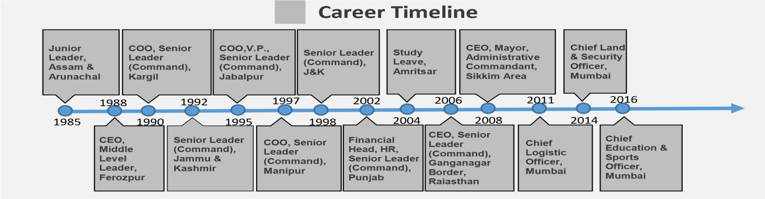

**YOU DARE - JUST LIKE I DO**



# 

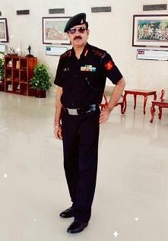

**MYSELF LAST TIME IN UNIFORM AT BCCI ENCLOSURE WANKHADE STADIUM MUMBAI**

**z**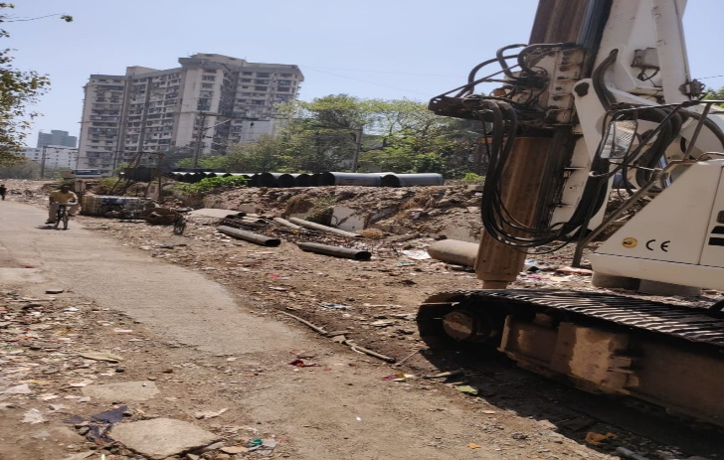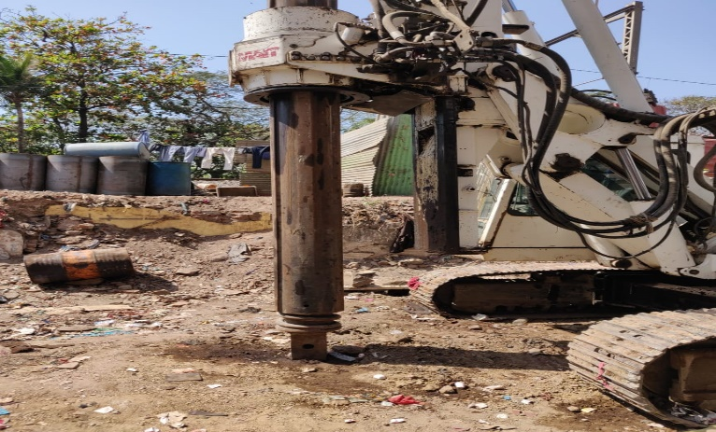

**on MY RECOMMENDATIONS TO RAILWAYS FOR AN ALTERNATE RAILWAY LINE FOR GOODS AND DEFENCE TRAINS FROM KURLA TO WADALA Stations IN 2013 (IN CASE DADAR GETS CUTS OFF) – WORK HAS COMMENCED - FEELING EXTREMELY SATISFIED ON MY CONTRIBUTION FOR GOOD CAUSE**

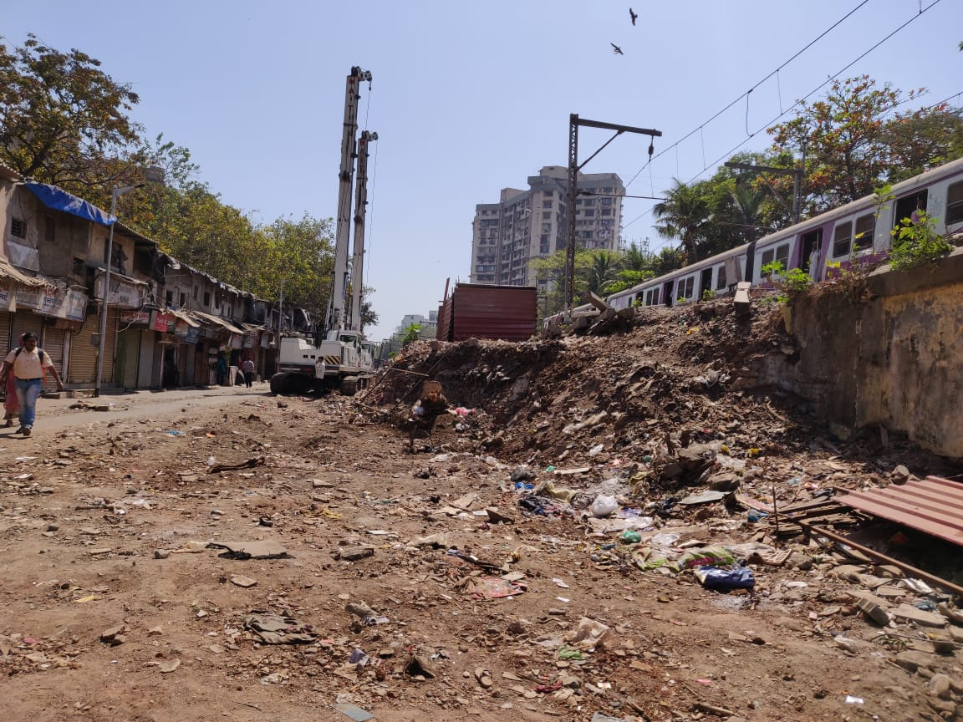

**YOU DARE - JUST LIKE I DO**