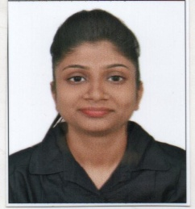**Puja khemka**

93,d block vip bangur

KOLkata-700055

Contact - 9007687715

Email Id- khemkapuja5@gmail.com

**OBJECTIVE**:To work with the company offering excellent customer service, and strong commitment to ensure passengers safety and comfort all the times.

**QUALIFICATIONS**:

**EDUCATIONAL QUALIFICATION**

* Completed Graduation from Maharani kasiswari college in the year 2016.
* Passed class 12th from Gyan bharati school in the year 2013.
* Passed class 10th from Gyan bharati school in the year 2011.

**HOBBIES:** Singing,Reading books,Watching movies,Travelling.

**PERSONALITY TRAITS:** Punctual, flexible, Positive, Confident.

**PERSONAL DETAILS:**

Date of Birth- 23rd feb 1995

Gender- Female

Marital Status-Single

Passport - R0457944

Date of Issue-18th may 2017

Date of expiry- 17th may 2027

Father’s Name- Late kamal kumar khemka

Mother’s Name - Manju khemka

**LANGUAGES KNOWN:**

|  |  |  |  |
| --- | --- | --- | --- |
| Speak | Read | Write | Language |
|  |  |  | Hindi |
|  |  |  | English |
|  |  |  | Bengali |
|  |  |  | Marwari |

**PHYSICAL FACTORS:**

|  |  |
| --- | --- |
| 162CM | HEIGHT |
| 44KG | WEIGHT |
| NORMAL | EYE SIGHT |

PLACE -

DATE - PUJA KHEMKA