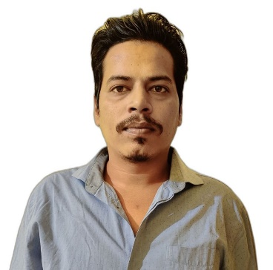 **Vineet Singh**

**Data Analyst & Data Scientist**

**Contact No.:- 9179133968 / 7566830155**

**E-Mail:- vineet11singh39@gmail.com**

**LinkedIn URL:- https://www.linkedin.com/in/vineet-singh-bb9b4785/**



**SUMMARY**

**A highly-skilled focused engineer with data science professional degree certification. Excellent in using advanced analytical techniques to analyze, mine and infer business insights. Seeking an opportunity to leverage my diverse skills in data mining and analysis into the open data analyst or data scientist position at your company to improve corporate performance.**

**TECHNICAL SKILLS**

* **Programing languages: R, Python, SQL.**
* **Visualisation tools: Tableau, Microsoft Power BI.**
* **Processing Framework: Jupyter Notebook, Anaconda.**
* **Operating Systems: Microsoft/UNIX/XP.**
* **Other: MS Word, Advanced Excel, MS Access.**

**CORE SKILLS**

* **Data Wrangling/Munging/Manipulation**.
* **Data Cleaning & EDA.**
* **Different kind of Dashboards.**
* **Statistical modeling And Visualisation.**
* **Machine learning algorithms**

**SOFT SKILLS**

* **Ability to work within highly dynamic and fast paced environment.**
* **Skilled communicator with excellent verbal, written, presentation skills with ability to grasp and simplify complex process interactions to others.**
* **Ability to implement business needs into technology.**
* **Inquisitive, curious and creative.**
* **Outstanding abilities to work in a team environment and handle responsibilities**.

**INTERNSHIP EXPERIENCE**

* **One year work experience as Data Analyst & Data Scientist in AI Variant.**
* **Their collect the Data from different sources and data manipulation/ cleaning & EDA, find business insight with ML algorithms, make the different kind of visualization & Dashboards.**

**CERTIFICATION**

* **Course Completion Certification of Data Science with distinction by ExcelR.**
* **Course Completion Certification of Data Analysis with distinction by ExcelR.**

**PROJECT WORK:**

**DATA SCIENCE PROJECT;**

**Project: Apple stock market prediction & Analysis.**

**Project: Mushroom classification Edible or Poisonous.**

**Project: Agriculture crop optimization.**

**DATA ANALYSIS PROJECT;**

**Project: IPL Analysis**

**Project: HR Analytics.**

**Project: Bank loan Analytics.**

**ACADEMIC CREDENTIALS;**

* **Bachelor of Engineering in Mechanical Stream from S.G.S.I.T.S. Indore (M.P.)**
* **Diploma in Mechanical Stream from J.P.T.C. Rewa (M.P.)**

**APPRECIATION AND EXTRA CURRICULAR ACTIVITIES;**

* **Active participation in various technical events in college level.**
* **State Level Hockey tournament participation.**
* **Inter-College Cricket tournament participation and Winner as Captain.**
* **Inter-College Volleyball tournament participation and Winner.**

|  |  |
| --- | --- |
| **PERSONAL DOSSIER** |  |
| **Date of Birth:** | **11-November-1995** |
| **Gender:** | **Male** |
| **Nationality:** | **Indian** |
| **Marital Status:** | **Unmarried** |
| **Linguistic Abilities:** | **English & Hindi** |
| **Address:** | **Dhawari, Lane no.-3,New sahijana bhawan, Satna (M.P.)** |

**I hereby declare that the above-mentioned details are true to the best of my knowledge. Any proof or evidence will be furnished on request.**

**Place: Pune** **Vineet Singh**