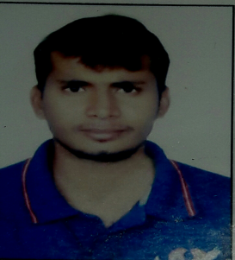

**CURRICULAM VITAE**

Name : Sudhir Jitendra Dubey

**Address: - Room No.208, Sai Prasad Bldg.,**

**GDB Ambedkar Road,**

**Parel Bhoiwada - 400012**

**Date of Birth :10th June, 1990**

**Phone No.: 9892272313**

**Email ID: sd965929@gmail.com**

Academic Details :

* **BCA Pune University Passed 69.00%**
* **H.S.C Allahabad University Passed 50.00%**
* **S.S.C. Allahabad Board Passed 50.00%**

**Experience :**

**6 Yrs. work as A Back Office Inventorisation in Datalink on client site P N Writer from 5th January to Till Date.**

**Responsibilties :**

* **Bank Documentation & Checking**
* **Document verification & cross verify in mail**
* **List of document checking & send to Kotak Branch Department.**
* **Prepare Excel for mainting all document details.**
* **Handling VLookup, HLookup, Pivot Table & All formula**
* **Guide All Colleagues upload all important document in Mail Site.**
* **Handling all Critical Cases in Doucument & after that upload in system.**

**Other Information :**

* **NATIONALITY : - Indian**
* **MARITAL STATUS : - Married.**
* **LANGUAGES KNOWN : - Hindi,English& Marathi**
* **HOBBIES : - Playing Cricket And Mobile Games**

**Date : Sign : Sudhir Dubey**