**BIO DATA**

Name : Jyoti Prakash

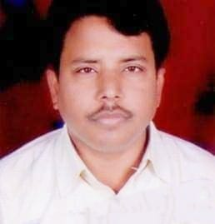

Mobile No : 9636241078

Email ID : jyotiprakash2477@gmail.com

Gender : Male

Date of birth : 01/10/1977

Nationality : Indian

Religion : Christian

Father’s name : Ram Prakash Peter

Mother’s name : Martha Peter

Languages Known : Hindi / English

Hobbies : Books reading

Address : D-57, Janta nagar, Rakri, Ajmer road , Sodala ,Jaipur,

302006, Rajasthan

**EDUCATIONAL BACKGROUND**

Elementary : 10th Ajmer Board (50 %) Year of passing : 1994

High School : 12th Ajmer Board (53.38 %) Year of passing : 1998

College : BA. Rajasthan University (50 %) Year of passing : 2005

Other Courses : Lab technician Bikaner Year of passing : 2001

**WORK EXPERIENCE**

**1.Company Name – World Vision India**

**About company - World Vision work through programmes focused on ensuring access to nutrition, healthcare, water and sanitation, quality education and livelihood for the sustained well-being of children. Ensuring a secure childhood is paramount to our work, which we strive to fulfil by building communities that are safe and fit for children. Position – Community Development Facilator**

**Work period – Since 2010 to 2023**

**2.Poly made medical company Work Period- 1999 to 2000**

**Position – Store keeper**

**3. BTH degree from Allahabad Bible College Period – 2 years**

Place : Jaipur

Date : Signature