**RESUME**

**M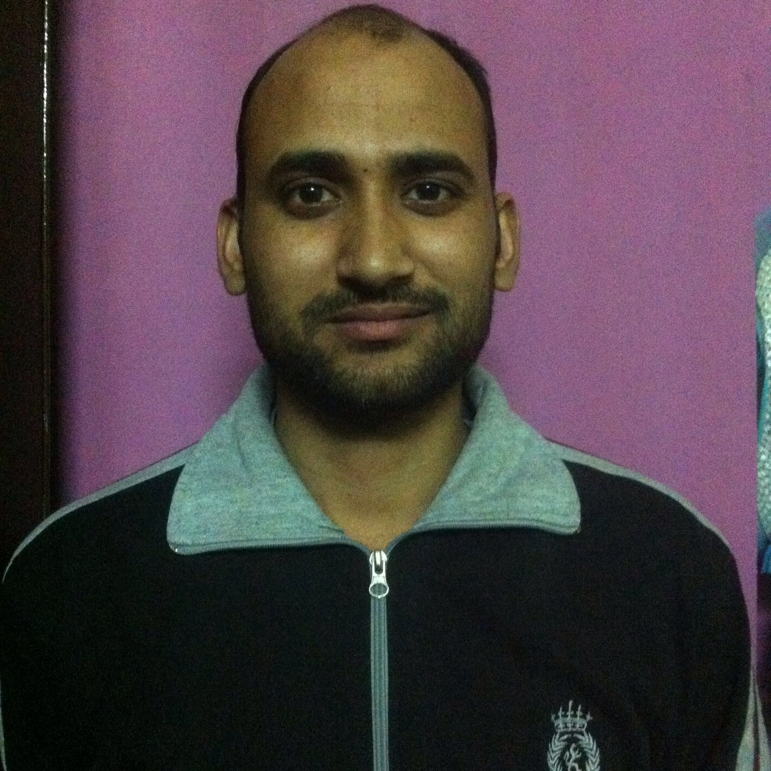ANOJ MANDAL Contact- H.No- 160, Sec 3,**

**Faridabad, Haryana-121004**

**Mobile- +91-8285984643**

**CAREER OBJECTIVE**

To work at a designated position in an organization and to perform to the best of my abilities, using my skills and knowledge.

**EDUCATION QUALIFICATION**

* Diploma (Mech.) from Delhi University
* 10th from H.B.S.E

**PROFESSIONAL QUALIFICATION**

* Basic knowledge of Ms-Office
* Knowledge of Internet Explorer
* Knowledge of Mechanical Equipments
* Operator Trainer of Automobile Parts
* Production and Quality Shop Floor Supervisor

**EXPERIENCE**

* Working from last 8 Years as a Supervisor Shop Floor in VeeGee Industrial Pvt. Ltd N.I.T Faridabad.

**COMPANY PROFILE**

Veegee Industries Pvt. Ltd is well known company in Automotive sector ISO/TS 16949, ISO 14001. OHSAS 18001 certified Veegee Industries Pvt. Ltd. Is a manufacture and supply of sheet metal parts to Maruti Suzuki India Ltd, Honda Seal Car India Ltd, JCB, JBM, CAPARO, Autolive, Bridge Syone, Trelliberg and Mahindra.

**STRENGTH**

* Quick learner and hardworking.
* Flexible and have never ending zeal to learn & innovat.

**PERSONAL SKILLS**

* Positive Attitude
* Team Player
* Challenging Environment
* Hardworking

**HOBBIES & INTERESTS**

* Listening music
* Playing Chess
* Bike Riding

**PERSONAL PROFILE**

**Name : Manoj Mandal**

**Date of birth : 12th June 1988**

**Nationality : Indian**

**Marital Status : Married**

**Language known : English, Hindi**

**Permanent address : H.NO- 160, Sec-3, Faridabad**

**Pin Code- 121004, HARYANA**

**Email id : manoj.mandal4643@gmail.com**

**DECLARATION**

I hereby declare that the information furnished above is true to the best of my knowledge. In case of any error or omission of data, I shall be liable for the consequences including termination of my employment.

**MANOJ MANDAL**