**SELVAKUMARI KAMARAJAN**  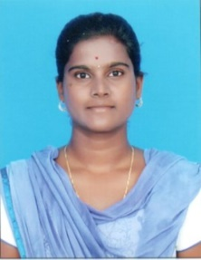

**9566327340, selvakumarikamarajan07@gmail.com**

17,chinna venkata swamy street, sanrorkuppam, Ambur

Thirupattur district,TamilNadu-635814

**OBJECTIVE**

**A job at your firm is my 1st experience, and I believe working at such cutting-edge design firm will inspire me to enhance my skills and collaborate within a positive atmosphere.**

**EDUCATIONAL QUALIFICATION**

|  |  |  |  |
| --- | --- | --- | --- |
| **COURSE** | **UNIVERSITY** | **YEAR OF PASSING** | **PERCENTAGE** |
| MCA | ANNA UNIVERSITY | 2020 | 76 |
| BCA | THIRUVALLUVAR UNIVERSITY | 2018 | 78.6 |
| HSC | STATEBOARD | 2015 | 81.5 |
| SSLC | STATEBOARD | 2013 | 93.6 |

**PERSONAL STRENGTH:**

* GOOD IN SELF LEARNING.
* INTEREST TO LEARN NEW THINGS.

**GOOD IN:**

* WEB APPLICATION DEVELOPMENT.
* DESIGNING.

**EXPERIENCE:**

I have worked for a year as a transaction processing associate in the Accenture private limited from Oct 2020

**PERSONAL SKILLS:**

HONESTY

TEAM SPIRIT

ACCEPTING CHALLENGES

**HOBBIES:**

* THROWBALL.
* HEARING SONGS.

**PERSONAL DETAILS**

**FATHER NAME :** KAMARAJAN N

**DATE OF BIRTH :** 18/10/1997

**BLOOD GROUP :** B+

**NATIONALITY :** INDIAN

**DECLARATION:**

I hereby that the details provided by is correct to the best of my knowledge and belief.