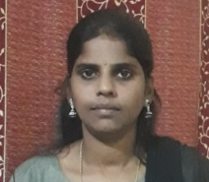 **Resume**

**PEESARI JYOTHI**

**Mobile: 9676730439**

**Email id:peesarijyothi610@gmail.com**

**Objective:**

Secure a responsible carrier opportunity to fully utilize my training and skills, while making a significant of contribution to the success of company

**Professional experience:**

* One year in business associate In vertex customer Pvt.Ltd, Hyd
* Two year telesales officer in Reliance General Insurance Company Pvt .Ltd,

**Educational qulification:**

* BTech from Malla Reddy Institute of Technology, JNTUH
* Intermediate From Gotham Junior College,
* SSC from wisdom high school

**Technical qualification :**

* MS office

**Strengths:**

* Ability to work in team

**Personal Details:**

* Name : Peesari Jyothi
* Father Name : Peesari Raju
* Date of birth : 12-09-1989
* Maritial status : married
* Religion : Indian
* Nationality : Hindu
* Language known : English ,Hindi &Telugu
* Permanent Address : 12-2-35,Maruthi nagar,

Goodshed Road, Moosapet ,

Hyderabad, TS-500018.

**Declaration:**

I hereby declare that all information furnished above is true to the best of my knowledge and belief.

**Place:** Hyderabad

**Date:**

**(P.JYOTHI)**