AMRUTHA VIJAYAN

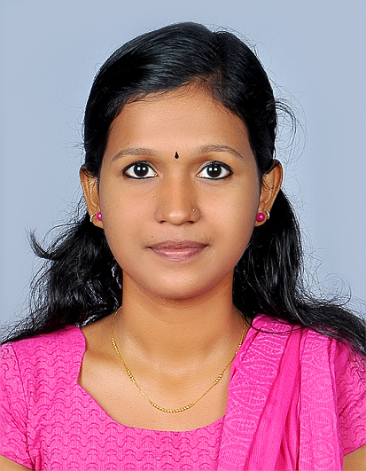

CHITTIATH HOUSE

P.O.PULLUR, URAKAM (VIA)

IRINJALAKUDA

**MOBILE: +91 9745692625**

**EMAIL : amruthavijayan70@gmail.com**

# Objective

To succeed in an environment of growth and excellence, provides me job satisfaction, self development and help me achieve personal as well as organization goals.

# Education

|  |  |  |  |  |
| --- | --- | --- | --- | --- |
| Course & Branch | Institution | Board/ University | Month/Year of Passing | Grade / Percentage  Of Marks |
| MBA | Holy Grace Academy of Management Studies, Mala | Calicut university | 2019 | Still pursuing |
| Btech/EEE | Vidya Academy of Science and Technology, Thrissur | Calicut university | 2017 | 73.2 |
| XII | Don Bosco HSS, Irinjalakuda | State board | 2013 | 89 |
| X | Don Bosco HSS, Irinjalakuda | State board | 2010 | 93 |

# Personal details

DOB. : 21/06/1995

GENDER : FEMALE

RELEGION : HINDU

CAST : EZHAVA

MARITAL STATUS : SINGLE

FATHER’S NAME. : VIJAYAN C.I.

MOTHER’S NAME : KAVITHA

**SOFT SKILLS**

* Time Management
* Good Listener
* Problem solving
* Team player

# PROJECT DETAILS

* Electrical Energy Audit
* Vehicular stopping system using GSM

**INTERNSHIP ;**

Industrial training at Kanjikode Wind Power Plant.

**PAPERS PRESENTED:**

Methods of harmonic analysis and reporting in future grid applications

# Awards and Acknowledgements

1. Participated in national energy auditing competition conducted by Energy Conservation Society (ECS).
2. Participated in the Master Class “digital strategy” by RVS educational institution, Coimbatore.
3. Successfully completed rock climbing, cave exploration and paragliding introductory programmes conducted at Vagamon under U.K.Palat.
4. Participated in shaping young minds programme conducted by All India Management Association(AIMA).
5. Participated in Euphoria 2017 conducted by sahrdaya college of advanced studies.
6. Participated in NUEVOZ 2017 conducted by the school of management studies ,Thiroor.

**INDUSTRAIL VISIT**

1. ACE RESISTORS,PLOT NO:12,HOOTAGILLI INDUSTRIAL AREA,MYSORE

2. KSIC SILK WEAVING INDUSTRY,MANANDAVADY ROAD,MYSORE

3. IDAMALAYAR POWER STATION

**DECLARATION**

I do hereby declare that all the information and details given above are true to the best of my knowledge

Place: Irinjalakuda Yours Sincerely,

Date: AMRUTHA VIJAYAN