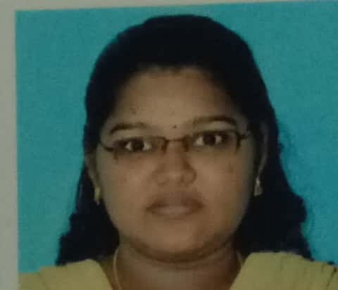 **16-A-Kumaravel street,**

**Mukkudal,**

**Tirunelveli District-627601.**

**Mobile No: 8760195747**

**Email: *kumarsangavi95@gmail.com***

***Resume***

**SANGAVI M.**

**Objective**

To involve actively in the challenging and participating in the profession where I can learn knowledge and expose my talents.

**Academic Qualification**

|  |  |  |  |  |
| --- | --- | --- | --- | --- |
| **Qualification** | **Institution** | **Board/University** | **Month and Year of completion** | **Percentage/CGPA** |
| M.Sc., (Biotechnology) | Lady Doak college, Madurai | Madurai Kamaraj university, Madurai | April 2018 | 85% |
| B.Sc., (Biotechnology) | Lady Doak college, Madurai | Madurai Kamaraj university, Madurai | April 2016 | 78% |
| Diploma in informatics for drug design | Lady Doak college,  Madurai | Madurai Kamaraj university, Madurai | April 2015 | 72.6% |
| H. Sc., | Sivanthi. Mat. Hr. Sec. School, Cheranmahadevi, Tirunelveli. | State Board, Tamilnadu | March 2013 | 79.6% |
| S.S.L.C | Sivanthi. Mat. Hr. Sec. School, Cheranmahadevi, Tirunelveli. | State Board, Tamilnadu | March 2011 | 85.2% |

**ADDITIONAL QUALIFICATION:**

Completed Hindi Exam up to Prathmic

**PERSONAL SKILLS:**

* Learned BASICS IN INFORMATION TECHNOLOGY
* Good presentation skills
* Fast Learner

**LAB SKILLS:**

MICROBILOGY LAB, BIOCHEMISTRY LAB, MOLECULAR BIOLOGY LAB, GENETICS, IMMUNOLOGY LAB.

#### **Areas of Interest**

* MICROBIOLOGY
* rDNA TECHNOLOGY

#### **PROJECT**

* Project on **“FORTIFICATION OF SOIL USING CHITOSAN FOR THE GROWTH OF TOMATO AND FENUGREEK FOR THE PROMOTION OF KITCHEN GARDENING IN MELLUR COMMUNITY**“ as part of the B.Sc., Biotechnology.
* Project on "**DOCKING STUDY OF CARMUSTINE AND ITS ANALOGUES WITH GLUTATHIONE REDUCTASE”** as part of diploma in Lady Doak College.
* Project on “**CHARACTERIZATION OF ALBUMIN-LOADED CHITOSAN ENCAPSULATED METAL NANOPARTICLE AND ASSESSMENT OF ITS APPLICATIONS IN HEALTH CARE**” as part of the M.Sc., Biotechnology.

#### **Qualities**

Self motivated and determined to fulfill any task assigned with full- fledged dedication.

#### **Conference/Seminar Attended**

* Participated in one day seminar on **“Conserve today for a better tomorrow**”organized byDepartment of Zoology and Biotechnology, lady doak college, Madurai held on 2016.
* Participated in seminar on **“Taking Research Bench to Bed Side”,** Lady Doak College, Madurai held on 2016.
* Participated in one day seminar on “**Nanotechnology: New Perspectives in Biomedical Applications**” organized by PG & Research Department of Zoology and Biotechnology, lady doak college, Madurai held on 2017.
* Participated in four day seminar on “**Applications of Bioinformatics Tools in Molecular Taxonomic Studies**”, organized by DBT-BIF centre, Department of Biotechnology, Lady Doak College, Madurai. 2017.

**ACHIEVEMENTS:**

* CERTIFICATE- for second prize in the examination on “MY EXPERIMENTS WITH TRUTH” organized by Gandhi Study Centre, Chennai, 2014.
* CERTIFICATE- for First prize in MEMORY GAME in WEBS AND SIBS CLUB organized by the Department of Biotechnology, Lady Doak College, Madurai. 2016.
* CERTIFICATE- for third prize in DUMB CHARADES in WEBS AND SIBS CLUB organized by the Department of Biotechnology, Lady Doak College, Madurai. 2016.
* CERTIFICATE- for second prize in CONNECTION in WEBS AND SIBS CLUB organized by the Department of Biotechnology, Lady Doak College, Madurai. 2017.
* CERTIFICATE- for third prize in QUIZ in WEBS AND SIBS CLUB organized by the Department of Biotechnology, Lady Doak College, Madurai. 2017.
* CERTIFICATE- for second prize in MEMORY GAME in WEBS AND SIBS CLUB organized by the Department of Biotechnology, Lady Doak College, Madurai. 2018.
* CERTIFICATE- for second & third prize in DUMB CHARADES,BIO-MEHANDI in WEBS AND SIBS CLUB organized by the Department of Biotechnology, Lady Doak College, Madurai. 2018
* CERTIFICATE OF MERIT- for third prize for proficiency in SUPPORT ALLIED in B.Sc. Biotechnology, Lady Doak College, Madurai, 2014.
* CERTIFICATE OF MERIT- for third prize for proficiency in LAB in Lady Doak College, Madurai, 2017.

**Languages Known:**

* Tamil
* English
* Hindi(read and write)

**Personal Information**

|  |  |
| --- | --- |
| **Date of birth** | 04-08-1995 |
| **Sex** | Female |
| **Father’s Name** | S. Mahendra Kumar |
| **Father’s Occupation** | Business Man |
| **Nationality** | Indian |
| **Marital Status** | Single |
| **Religion** | Hindu |

#### **Declaration**

I hereby declare that all the information furnished above is true to the best of my knowledge.

Place : Tirunelveli.