**RESUME**

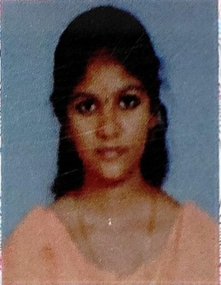

Jeevitha H

No:40, 2nd Floor, Ganga Kaveri Street,

Vigneshwara Nagar, Porur,

Chennai – 600 116

[jeevithakrishnan96@gmail.com](mailto:jeevithakrishnan96@gmail.com)

**8939548548**

**CAREER OBJECTIVE**

To sincerely apply my knowledge and skills in the given job responsibility and be a continuous learner to handle challenges and challenging situations.

|  |  |  |  |  |
| --- | --- | --- | --- | --- |
| COURSES | INSTITUIONS | UNIVERSITY | YEAR OF PASSING | PERCENTAGE |
| M.A. Business Economics | Ethiraj College for Women | AUTONOMOUS (Affiliated to Madras University) | 2018 | 61% |
| B.A. Economics | Ethiraj College for Women | AUTONOMOUS (Affiliated to Madras University) | 2016 | 58% |
| HSC | Meenakshi Matric. Hr. Sec. School | State Board | 2013 | 70% |
| SSLC | Sri Krishnammal Matric. Hr.Sec. School | State Board | 2011 | 52% |

**EDUCATIONAL QUALIFICATIONS**

**TECHNICAL QUALIFICATIONS**

* MS-OFFICE
* Typing

**STRENGTHS**

* Leadership & Team Worker
* Positive Thinker

**HOBBIES**

* Drawing
* Listening to music

**EXTRA CURRICULAR ACTIVITIES**

* Participated in Dramas in School.
* Got 1st Place in Kho - Kho in School.

**WORK EXPERIENCE**

**August 2018 – Present:**

* Company : Greater Chennai Corporation, Ripon

Building

* Department : Educational Department
* Position : Computer Assistant

**PERSONAL DETAILS**

Father’s Name : Mr. T.R. Hari Krishnan

Nationality : Indian

Date of Birth : 11.04.1996

Alternate Contact Number : 9710272782

Languages Known :

|  |  |  |  |
| --- | --- | --- | --- |
| **LANGUAGE** | **READ** | **WRITE** | **SPEAK** |
| Tamil |  |  |  |
| English |  |  |  |
| Telugu | **-** | **-** |  |

**DECLARATION**

I hereby declare that the above information are true and correct to the best of my knowledge.

**Place:** Chennai

**Date :**

(H.Jeevitha)