**RESUME**

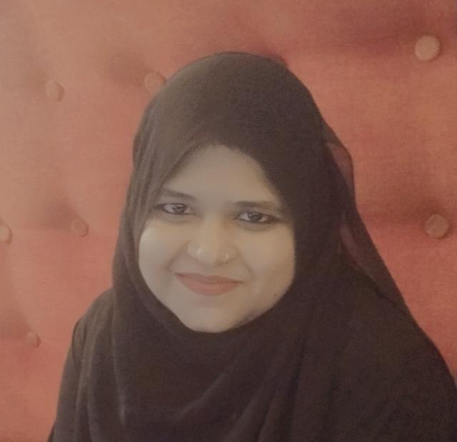 **FIRDOSE ZAMA**

**Phone: 9019421438**

**Email:firdoseayesha14@gmail.com**

**CONTACT ADDRESS**

No.629,10thmain, 3rdcross, Begur Road, Bommanahalli, Bangalore–560068.

**CAREER OBJECTIVE:**

To be a part of a growing and dynamic organization, that offers a challenging career that helps to Maximize my exposure and improves my professional skills while contributing to the progress of the organization.

**ACADEMIC PROFILE:**

I have completed Bcom from maharani’s art’s, commerce, science college from Bangalore on 2017

**PROFESSIONAL EXPERIENCE**

* 6 months worked in HGS as a CRO (May 2017 – Jan 2018)
* 4 years experience in Flipkart internet private limited Company as a Senior CRM and experienced in Email-Support (Apr 2018 – May 2022)
* 1 year experience in slice as customer support executive in Email support. (May 2022 – Current year)

**ROLES AND RESPONSIBILITIES**

* HGS has proved to be a blessing in my professional career. This place has given me a role which requires coaching and supporting new employees, and provide them knowledge and skills.

* Employees are encouraged to be a part of the process which combines a deep knowledge and technology. We learn various programs offered through the weekly games, gyms, celebrations, parties which enhance our skills.

* Responding to service, product, technical, and customer relations questions on subjects such as features, specifications, and repairs on current and discontinued products, parts, and options, based on customer entitlement.

* FLIPKART has provided a great platform to perform with a good skills in company.

* FLIPKART has given a wide role to prove myself with my hard work in different processes.

* Best opportunities and Good knowledge provided to the Employees who are eager to learn.

* Employees are provided EGVs for their best top performance for month on month.

* Responsible towards technical, developer, design, and process planning with new updates day by day.

* Enhancing Escalations of Customers and provided TOA in the customer favour and giving a positive response to the customer which builds friendly relationship with positive resolutions.

* Healthy and Happy FLIPKART family with the responsibilities of values, fashion and mission.

* Email Support in handling customer query.

* Experience using help desk software and remote support tools.

* Excellent communication and problem-solving skills.

* Keeping records of customer interactions and transactions, recording details of inquiries, complaints, and comments.

**PERSONAL STRENGTH**

* Eager to learn and work o Confident
* Hard Working

**SKILLS**

People management, reporting, handling escalations, sharing team productive reports, providing and implementing ideas related to product knowledge, Feedbacks and providing improvements related to process and tools.

**TECHNICAL SKILLS**

• Social media monetization, Facebook and Instagram ads run, Digital marketing, Basic Canva editor expert**.**

**LANGUAGES KNOWN:**

* English o Kannada
* Hindi

**PERSONAL DETAILS:**

**Father Name :** Vazeer Basha

**Mother Name :** Fareeda

**Sex :** Female

**DOB :** 26/07/1996

**Nationality :** Indian

**Marital Status :** Married

**HOBBIES:**

* Playing Games

**DECLARATION:**

**I here by declare that above mentioned information is true to the best of my knowledge and belief.**

**Date:-**

**Place:-Bangalore FIRDOSE ZAMA**