**CURRICULUM VIATE**

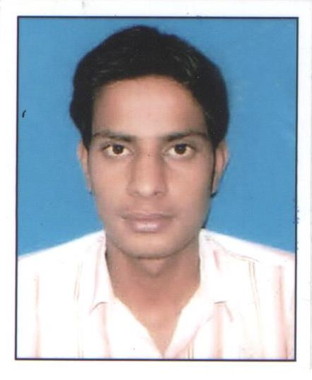

**KALPNA ROKA**

Add: # 1444/20 Sec29 B

Chandigarh

160030

Cont no- 08146387895

Email id- katemogz1@gmail.com

**CAREER OBJECTIVE:-**

Focused, ambitious and results driven student an opportunity to work with a reputable firm that will enable me utilize my skills for the benefit of the company.

To be a part of an organization which gives me opportunities to utilize my talents and achieve

Professional growth though hard work and dedication..

**ACADEMIC QUALIFICATION:-**

* Passed High School with 1st division from H.P.Board on March 2010
* Passed Intermediate (Commerce) with 1st division from H.P.Board on March 2012
* Graduate (B.com) with 2nd division from H.P. Univ. on March 2015.

**WORK EXPERIENCE:-**

* 1 Year experience as Sales Executive in **DEN SNAPDEAL TV – SHOP**

.

**PROFESSIONAL QUALIFICATION:-**

* + Basic knowledge of M.S.Office, English Typing and Internet Operate.
  + Knowledge of Window XP, Window 7, Window 8,Window 10

**INDUSTRAL TRAINING:-**

* **Aptech Certified Professional Accountant**

**HOBBIES:-**

* Playing Badminton,
* Playing Videogame.
* Listening Music

**PERSONAL DETAIL:-**

* Mother’s Name : Mrs. Tara Roka
* Father’s Name : Mr. Bakhat Roka
* Date of birth : 05-feb -1995
* Gender : Female
* Language knowledge : Hindi, English
* Marital Status : Single
* Nationality : Indian

I have declared that the above mentioned information is true to best of my knowledge.

Date:…………… Signature

Place…………….  **( KALPNA ROKA )**