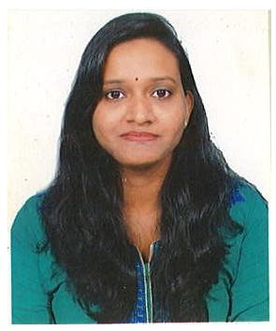

# NEELAM SAMEER SHET TANAVADE

Mobile: 9923883354

## E-mail: [neelam.tanavade@gmail.com](mailto:neelam.tanavade@gmail.com)

CTC 2.40 Lacs

**OBJECTIVE:**

* To work in an organization, where I can utilize my knowledge, experience, management skill & experience in the field of Business Management effectively & efficiently & thus achieve new goals in my career.

**SYNOPSIS:**

* Recruitment of Agent & Development of agent.
* Doing join calls with them. & Day to day report.

**PROFESSIONAL EXPERIENCE**

* Worked with at **Reliance Nippon life insurance company** as **Sales Manager** in Margao branch From June 2016 to December 2017.
* Recruitment of agent advisors
* Training and develop them
* Going for calls with them in field work
* Maintain MIS Track record for own performance
* Motivating Agents and tracking them on daily basis for insurance business
* To grow the agency business to targeted GPW numbers with a team of agents in the branch.
* Tracking & enabling performance of the agent advisor on a regular basis.
* Worked at IDBI Bank as Sales Manager used to handle South Goa branches. July 2015 to Jan’2016
* Worked at HDFC Bank as Sales & Development Manager in Chicalim Branch. From April 2012 to November 2014.

**ACHIVEMENTS:**

* Awarded medal for Recruitment expert
* Rewarded with Certificate from CEO
* Achieved reward of fastest recruiter 5 recruitments single day

**PROFESSIONAL QUALIFICATION:**

* Master’s In commerce in 2012.
* Bachelor In Commerce in 2009.

**ACADEMIC QUALIFICATION:**

* Passed S.S.C. from Goa University in 2002.
* Passed Higher Secondary from Goa Board in 2005.

**ADDITIONAL QUALIFICATION:**

* Diploma in Aviation in 2007.

**COMPUTER SKILL:**

* Operating System : Windows XP
* Office Tools : MS Word, MS Excel, MS PowerPoint, Tally

**Personal Detail:**

Husband Name Sameer N. Shet Tanavade

Marital Status Married

Date of Birth 07.01.1986

Nationality Indian

Corr. Address: H.No.387, Bhute-Bhat, Near Mestawada, Vasco Da Gama

Goa – 403802

Current Address: B.R residency, Vasant Nagar, Gogol, Margao.

Languages Known Hindi, English, Marathi & Konkani

Hobbies Reading, Writing, Go Carting, Stage Drama Participation.

I hereby declare that above written particulars are true to the best of my knowledge & belief.

**Date:**

**Place:** Margao (**Neelam S. Shet Tanavade)**