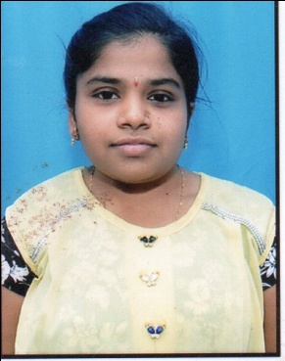  **AVOOSALI.SWETHA**

EMAIL.ID: Swetha.avoosali248@gmail.com

+91-7036266189

-----------------------------------------------------------------------------------------------------------------------

**CAREER OBJECTIVE**

To work in the challenging position in an organization that provides ample opportunities to learn and to contribute.

**TECHNICAL SKILLS**

* **MANUAL TESTING:**
* Expertise in **SDLC** and **STLC** concepts.
* Expertise in identifying Test scenarios.
* Well versed in **Defect life cycle.**
* Good Knowledge in Smoke, Functional, Integration, System Testing.
* Awareness on **SDLC** models.
* Very good Knowledge on **AGILE** Model.
* Extensive Knowledge with Test Plan Concepts.
* **CORE JAVA:**
* Good knowledge on Method Overloading, Method Overriding.
* Knowledge on **OOPS** concepts like Inheritance, Polymorphism, Abstraction and Encapsulation.
* Knowledge on **Type Casting**.
* Very good knowledge on **Constructors** and **Interface**.
* **SELENIUM:**
* Very good knowledge on **High level/Low level Architecture.**
* Good Knowledge on **Xpath and Handling Pop-up.**
* Knowledge on **Synchronization**.
* Very good Knowledge on **FindElement** and **FindElements**.
* Awarness on **pop-up.**
* Knowledge on **Automation frame work.**

**ACADEMIC QUALIFICATIONS:**

* B.Tech(EEE) at Malla Reddy Engineering College(A), Hyderabad with 77.81%(2018).
* Intermediate at Narayana junior college , Hyderabad with 81.60%(2014).
* SSC (10th) at Gandhi memorial high school, Zaheerabad with 8.0 GPA(2012).

**PROJECT**

* **Mini project**

**Title**: Design of earth fault relay for 1-phase power system with feeder protection.

* **Major Project**

**Title:** Power Quality Improvement in Zeta Converter for BLDC Motor Drives

**STRENGTHS:**

* Positive attitude.
* Good analytical logical skills.

**Co-CURRICULAR ACTIVITIES:**

* Attended a workshop on roboventures
* Attended a workshop on PLC&SCADA
* Participated in project expo held in our college technical fest on thermal electric generator.
* Co-Ordinator for the Two Days National Level Techno-Cultural fest “AKSHARA -2k17”

**PERSONAL PROFILE:**

Father’s Name : Avoosali .Ashok chary

Date of Birth : 19-04-1996

Gender : Female

Nationality : Indian

Religion : Hindu

Languages known : English, Hindi and Telugu

Permanent Address : H.NO:13-80, N.G.O’S colony, Zaheerabad,

Sangareddy, (Dist) - 502220.

**DECLARATION:**

I hereby declare that the above mentioned information is correct and I bear the responsibility for the correctness of the above mentioned particulars.

**Place : HYDERABAD**

**Date :**

**(Avoosali Swetha)**