# PROJECTS

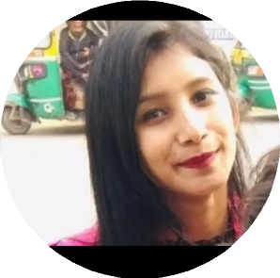

**Mamta**

Chattarpur,

110068 New delhi, India [bishtm710@gmail.com](mailto:bishtm710@gmail.com) 9310407055

[Mamta](https://www.linkedin.com/in/mamta-bisht-24b962244/)

29/08/2000

## NETFLIX CLONE

## WHATSAPP CLONE

# CERTIFICATES

[Deep Neural Networks with PyTorch](https://coursera.org/verify/SFBXFSNZ4CP3)

[Introduction to Computer Vision and Image Processing](https://coursera.org/verify/YMHHKZSKWUZC)

[Introduction to Deep Learning & Neural Networks with Keras](https://coursera.org/verify/H227VFQNZ68P)



**EDUCATION**

## Intermediate

*Sarvodaya Kanya Vidyalaya No. 01*

04/2017 – 03/2018 | New delhi, India

## High school

*Sarvodaya Kanya Vidyalaya*

04/2015 – 03/2016 | New delhi, India

**Bachelor of Technology** *Noida Institute of Engineering & Technology*

Greater noida, India



**LANGUAGES**

Hindi , English



**INTERESTS**

Dance , Travel

# PROFESSIONAL EXPERIENCE

## Sales executive

*Advotis infotech sec-16, Noida*

09/2020 – 08/2021

(To enhance my communication skills , have command on English proficiency and learned how to work in professional environment with team).

# SKILLS

## Technical skills

JS

HTML CSS

React

## Interpersonal skills

Good communication skills Relationship Building Results-Driven

Problem Solver

**TOOLS**

Figma