**Curriculum vitae**

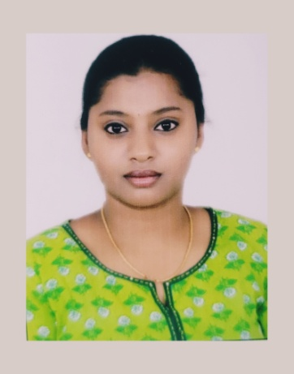

**NAME:** YASHASWINI SS

**EMAIL ID:** [**YashaswiniSS1314@gmail.com**](mailto:YashaswiniSS1314@gmail.com)

**PHONE NUMBER:** 9743163033/ 7975070608

**ADDRESS:** No 57, Near Maramma Temple, Avalahalli,

Mysore Road, Bangalore-560026

**OBJECTIVE:**

To seek an opportunity in a well known organization that allows me to develop and enhance my skills, and become a valuable part of the organization’s growth**.**

**EDUCATIONAL BACKGROUND:**

* MBA in Finance Specialization from Distance Education Gitam university Visakhapatnam in 2019 with CGPA 6.95
* Bachelor of commerce (BCOM) from Bangalore University Surana College in 2017 with CGPA 7.41
* Intermediate[2 PUC] from Government of Karnataka Surana College in 2014 with GPA 73.5
* 10th Class from Central Board of Education BBUL Jain Vidyalaya in 2012 with GPA 6.60

**SKILLS**:

* Knowledge of MS office (Excel, Word and Power Point) and Tally Prime.
* Ability to prepare Journal, purchase and sales entries.
* Knowledge of bank reconciliation.
* Basic knowledge about TDS and GST.
* Good communication skills verbal and written.
* Strong analytical and task completion skills.

**EXPERIENCE**:

* Worked in Jitendra Kumar Jain Auditor office for 6 months.
* Worked in RPAN Associates & LLP Auditor office for 6 months.

**PERSONAL INFORMATION:**

**Date of Birth**: 14/02/1996

**GENDER:** Female

**Fathers Name**: Shamanna G

**Mothers** **Name:** Sumana M

**Nationality:** Indian

**Marital Status:** Unmarried

**Hobbies:** Watching Movies, Listening to Music

**Language known:**

English, Kannada and Hindi

**DECLARATION:**

**I hereby declare all the information is true to the best of my knowledge and belief.**

**PLACE:**

**DATE:**

**SIGNATURE:**