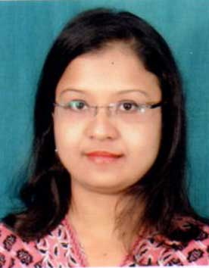

**CURRICULLUM VIATE**

**JYOTI LAHKAR**

**Mobile No.8638401500/9453049183**

**Email id: jyotilahkar25aug@gmail.com**

**Career Objectives:-**

**The ideal atmosphere would be to serve organization with the best exploitation of my expertise and innate skills coupled with aligning my goals and one in which new ideas are welcome and decision is required.**

**Academic Qualification:**

|  |  |  |  |  |
| --- | --- | --- | --- | --- |
| **Course** | **Year** | **Institution** | **University/Board** | **Grade/Div** |
| **AISSE** | **2004** | **KV,Narengi,Guwahati** | **CBSE** | **2nd** |
| **H.S** | **2011** | **Narengi Anchalik College**  **Narengi, Guwahati** | **AHSEC** | **1ST** |
| **B.Music**  **(Sattriya Dance)** | **2009** | **State College Of Music**  **Guwahati** | **G.U** | **1st** |
| **GUNIN (Norton)** | **2010** | **Maniram Dutta Muktiar**  **Sattriya Kalakendra** | **SSPP,Guwahati** | **1st** |
| **MSW** | **2012-19** | **IGNOU,New Delhi** | **IGNOU** | **1st** |
| **Certificate course in counslling** | **2019** | **Mind India** | **Mind India** | **1st** |
| **M.A (Human Rights)**  **(Child Rights & Development)** | **2016** | **Assam Don Bosco University Azara, Guwahati** | **ADBU** | **CGPA-7.06** |

**Any Award/Scholarship**

I was awarded scholarship as an young artist in the field of Sattriya Dance from Ministry of Culture, Govt. of India, New Delhi for Advance Training under Padmashree Ghanakanta Bora Borbayan (Mar.2009 toFeb 2011) and accordingly completed the professional training with performance in and out of Assam.

**Working Experience:**

* Worked as “Trainer”in the department of B.voc under TISS Guwahati center, since June 2016.
* Worked as “Documentator” under Child Friendly Guwahati (CFG) Project from January 2017 to April 2019.

Computer Literacy:

Basic Knowledge of Computer Application

Strength:

Good Command on local language

Willingness to work and learn.

Ability to work with and through people

**Personal Details:**

Father’s Name : NIRANJAN CH. LAHKAR

Mothers Name : ANITA LAHKAR

Permanent Address : Satgaon, Pragati Nagar

Bye lane No.8, House No.29

P.O.- Udayan Vihar, Guwahati

Kanrup (M), PIN-781171, Assam

Correspondence Address : Same as Above

Phone Number : +8638401500/9435049183

E-mail : <jyotilahkar25aug@gmail.com>

DOB : 25th August, 1988

Sex : Female

Nationality : Indian

Religion : Hinduism

Caste : General

Marital Status : Un-Married

Hobbies:

Dancing & Music

**Languages Known:**

Assamese, Hindi & English

**DECLARATION**

I do hereby declare that all information furnished above by me is true to the best of my Knowledge and belief. In case, if found false I am Liable for the termination from the job.

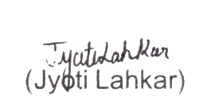

**Date: 8-11-2019**

**Place:**Guwahati.