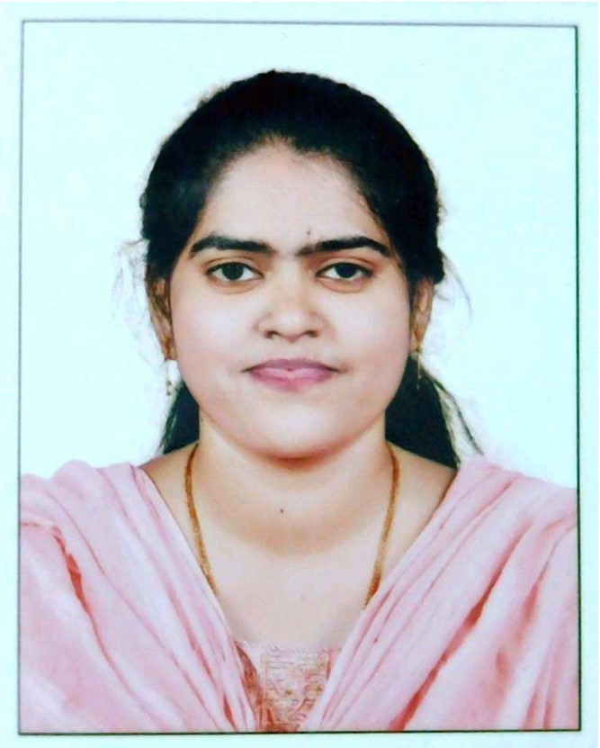

**Vimala** **Daniel** 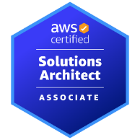

Flat No. 65, Door No. 6, Kamatchi Apartment,

Sekkadu, Balaji Nagar, Pattabiram,

Chennai-600072.

Mobile No: +91-9003134023, +91-7904992256

EMAIL ID: [elshaddai0111@gmail.com](mailto:elshaddai0111@gmail.com) / vimaladaniel01@gmail.com

OBJECTIVE

Seeking a quality environment where my Knowledge and Experience can be enriched and shared, also looking for an Opportunity where I can improve my Functional and Technical skills as well as Quality of work.

EDUCATION PROFILE

|  |  |  |  |
| --- | --- | --- | --- |
| QUALIFICATION | BOARD/UNIVERSITY | SCORE | Year |
| B.E(ECE) | Saveetha Engineering College | 8.2 CGPA | 2015 |
| Class XII | Vijayanta Hr. Sec. School | 89.33% | 2011 |
| Class X | Ordnance Clothing Factory School | 73% | 2009 |

PROFESSIONAL EXPERIENCE

I have overall 8 years of experience with 2 years of experience as AWS Devops Engineer.

I joined IBM India Private Limited on 15th Jul 2015 with full continuity of service, later services were transferred to Kyndryl Solutions Private Limited on 01st Sep 2021 pursuant to global restructuring of IBM’s Managed Infrastructure Service business to Kyndryl.

• Worked as a Devops Engineer from May 2020 till Mar 2023.

• Worked as a Linux Admin from Aug 2015 till Apr 2020.

AWS SKILL SUMMARY

* Experience in providing operations and maintenance support for AWS cloud resources such as launching, maintaining, and troubleshooting EC2 instances, S3 buckets, Virtual Private Clouds (VPC), Elastic Load Balancers (ELB), Relational Database Services (RDS), Backups, Route53, Cloud Watch and IAM.
* Experience in architecting and managing AWS cloud infrastructure.
* Expert in integrating various tools and application servers.
* Configure the servers with the Cloud Watch monitoring and monitor the performance metrics of the production servers.
* Knowledge in load balancing and set up load balancer and firewall rules in and enterprise environment.
* Manage Amazon instances by taking AMIs and perform administration.
* Use scripting languages like shell script.
* Experience with RDS and Dynamo DB tasks in AWS.
* Configure and update the servers using configuration management tools like Ansible and Service delivery management using Amazon AWS (EC2, ELB, Cloud Watch).
* Create custom sized VPC, subnets, NAT to ensure successful deployment of Web applications and database templates.
* Knowledge of using Routed Protocols: FTP, SFTP, SSH, HTTP, HTTPS and Connect direct.
* Install and configure Web Sphere/APACHE/TOMCAT server for Linux and Windows connectivity.
* Writing Terraform code to create EC2 instance and VPC with other services.
* Strong knowledge on AWS Services like EC2, EBS, S3, IAM, VPC, Load balancing, Auto scaling.
* Experience in Amazon EC2 in setting up instances, worked closely with infrastructure teams to troubleshoot complex issues and setting up security groups.
* Creating the VPC’s, configured the subnets, attached the gateway and routing tables to the subnets and deployed the EC2 instances in the subnets created.
* Configured AWS Identity and Access Management (IAM) users and groups for improved login authentication.
* Creating attaching, detaching and deleting of various volumes in AWS.
* Creating Elastic Load Balancer.
* Creating Auto Scaling group and attaching Load Balancer to it and Taking snapshots.

LINUX SKILL SUMMARY

* Linux server performance tunic.
* Installation of Software Packages and Patches
* Handling Incident tickets, Service requests and Change requests raise by the customers.
* Handling Server related problems: File System, Samba, DNS, slowness issues, iptables updating, hardware problems.
* New Server Built based on the request by client.
* Coordinating with Vendor for 100% server uptime.
* Monitoring Server utilization through monitoring applications.
* Hardware/firmware/ Upgradation of IBM switches.
* Experienced in LVM (Logic Volume Manager).
* Redhat os patching using centralized yum repository.
* Setting up FTP server, uploading & download data on to the FTP server & Configuration and administration of Samba.
* Setting up NFS server for network shares.
* File system management using fdisk mkfs, fsck & mount etc.
* Adding, creating new users groups and setup home directories.
* Working on Rsync and Scp command to backup data.
* Worked extensively on tar command and find command.
* Run the cron job for various task.
* Knowledge on booting process and run levels.
* Providing password less connections through SSH resolving issues.
* Providing sudo access to the users & groups.
* Monitoring performance issues using PS and top command.
* Security implementation through ACL, set uid, Set gid and sticky bit.

DEVOPS SKILL SUMMARY

* Hands on experience with DevOps tools Maven, Git, Jenkins, Ansible, Docker
* Extensively worked on Jenkins for setting up the CI/CD automation builds deployments.
* Experience in creating Dockerfile and Docker-Compose file managing the Images through Dockerhub Registry.
* Strong Knowledge in creating Docker Containers and Docker volumes.
* Builds, Configure, Manage and Coordinate all Builds and Release Management activities.
* Used MAVEN as build tools on Java projects for the development of build artifacts on the source code.
* Hands on experience using version control tools like GIT, GitHub
* Responsible for creating repositories and branches in GIT. GitHub
* Experience on merging code lines in the Git and resolved all the conflicts during merges.
* Creating Tags and Release Tags activities in Git.
* Build pipeline for continuous integration and deployment using Jenkins
* Strong knowledge on ANSIBLE and Hands on experience in writing playbooks.
* Manage the configurations of multiple servers using Ansible.
* Strong Knowledge in Kubernetes to orchestrate the deployment, scaling and management of Pods.
* Good Interaction with developers, managers and team members to coordinate job tasks and strong commitment to work.
* Strong knowledge and deployment experience in Apache Tomcat servers.

**CERTIFICATIONS**

AWSSolutions Architect Associate certified**:** 1285JVRC92BQ1G52

**PROFESSIONAL TECHNICAL SKILLS**

|  |  |
| --- | --- |
| CI Tools | Jenkins |
| Databases | Mysql |
| Operating Systems | Windows And Linux. |
| Iaac | Terraform |
| Versioning tools | Git, GitHub |
| Application Servers | Apache Tomcat |
| Cloud Computing Tool | Amazon web services |
| Containerization | Docker. |
| Orchestration tool | Kubernetes. |
| Configuration Management | Ansible |
| Languages and Scripting | Shell |
| Repository Management | Nexus |
| Build Tools | Maven |

**PERSONAL INFORMATION:**

Date of Birth : 01-11-1992

Gender : Female

Father name : Mr. Daniel S

Mother tongue : Tamil

Nationality : Indian

Marital Status : Single

Languages : English, Hindi (read and write) and Tamil

Permanent address : Flat No.65, Door No.6, Kamatchi Apartment, Balaji Nagar,

Sekkadu, Pattabiram, Chennai-600072.

**DECLARATION**

I consider myself familiar with Information technology aspects. I am also confident of my ability to work in a team. I hereby declare that the information furnished above is true to the best of my knowledge.

Place: Chennai Signature

Date: (**D. VIMALA**)