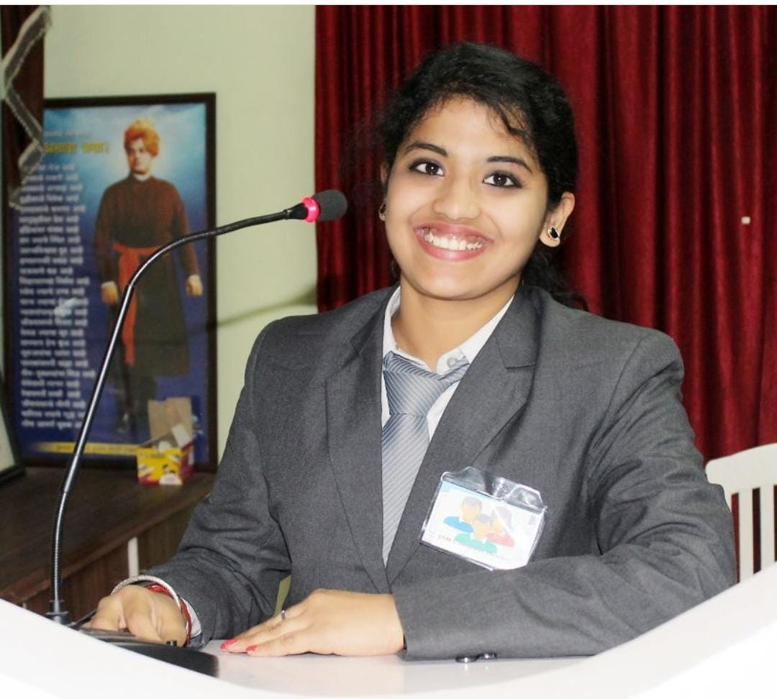

SALONI PANDE JAIN

*Relationship Manager (RM), ICICI Bank*

8208737717/8237231011

[jain1011saloni@gmail.com](mailto:jain1011saloni@gmail.com)

304C, Golden Trellis, Balewadi, Pune – 411045

Indian

12/12/1995



**Objective**

To be a successful manager in an organization by making effective use of my skills and knowledge along with good communication skills in the most appropriate way with strong ethical values to contribute towards the development of the organization.



**Professional Summary**

I am Dedicated **Relationship Manager** who can provide thoughtful and trustworthy customer solutions and financial option exploration. Adept at providing personalized banking advice and services, developing customer relationships, and processing deposits and funds. Specialize in providing comprehensive and reliable customer service and assistance.



**PROFESSIONAL EXPERIENCE**

07/19 – present Pune, India



* CASA (Current Account Savings Account)
* Fixed Deposits (FD)
* NRI Account
* Forex
* Mutual funds and Demat Account
* Remittances
* Corporate Accounts
* Assets – Personal Loan, Gold Loan, Education Loan, Business Loan, Home Loan, Auto Loan.
* SMEG Loan’s
* Insurance – General, Life.
* 360 Degree Retail Branch Banking

**Relationship Manager,** *ICICI Bank Ltd.*

Understanding the needs of customer and advising appropriate products.

* Develop strategies for maintaining and further penetrating existing account.
* Support the Bank’s strong relationship banking culture through ongoing customer contact, quality customer service and superior product knowledge.
* Assisting customers in applying for loans for personal and business purpose.
* Provided personalized services to privileged customers and corporate sectors.
* Established professional client relationships and sold them banking products.
* Delivering professional and personalized customer service to corporate and individual.
* Handling escalation and documenting entire procedure.
* Effective Management of customer relationships and anticipation of customer’s financial needs on ongoing basis. Key Customer Relationship Management & supervision of High-Net-worth Customer Programs.
* Provide superior customer service.
* Cross sell of multiple banking products.

**PRODUCTS MANAGED**



**SKILLS**

Team work

Planning and execution Team handling

Sales and marketing Enthusiastic Operations



**ACHIEVMENTS**

* Topper in opening highest fixed deposit in the region for 3 consecutive months.
* Highest NFO sales in the region Last Year for March Quarter.
* Managed to open to MNC account of 10 crores funded from HDFC Bank and opened 13 crore FD for this account and opened corporate account for employees along with selling cross products to them.
* Opened 1 current account for MNC company with limit set to 4 crores.
* Won Best Relationship Manager Award for outstanding work and setting new benchmark for branch last fiscal year.



**EDUCATION**

08/2016 – 05/2018

Nashik, India

07/2013 – 06/2016

Aurangabad, India

07/2012 – 05/2013

Aurangabad, India

07/2010 – 05/2011

Aurangabad, India

**MBA- Finance,** *K.K Wagh College of Engg. & Research, Nashik* **B.Com - Economics,** *Deogiri College, Aurangabad*

**HSSC,** *Deogiri College, Aurangabad*

**SSC,**  *G.A Shah English School, Sillod*



**DECLARATION**

I hereby declare that the information furnished above is authentic and true to the best of my knowledge.