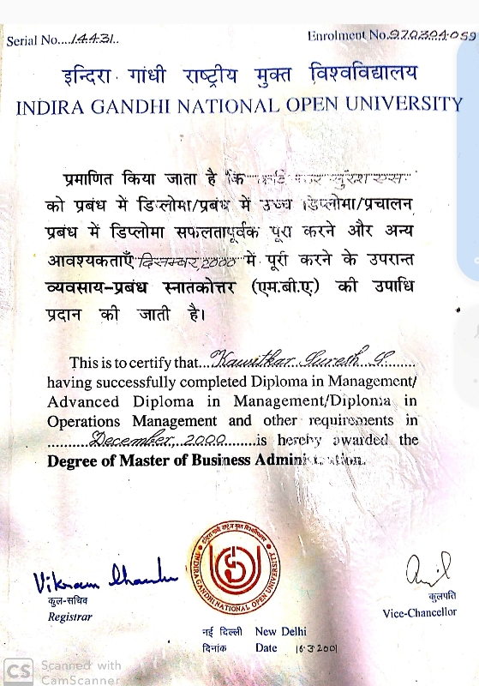RESUME

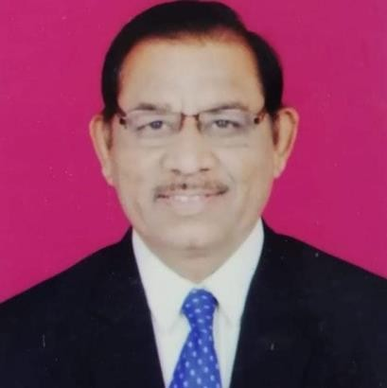Dr. Suresh Shriramji Kawitkar

MBA, Ph.D, MIE (Mechanical)

**Ex-HOD of Department of Business Management**

Vidya Bhrati Maha.Amaravti

**Ph.D Research Centre Co-Ordinater [MBA**]

Vidyabharati Mahavidyalaya, Amravati

**Veteran of Indian Air Force [from 07-01-1981 to 31-01- 2001]**

Date of Birth – 2nd May 1962

------------------------------------------------------------------------------------------------------------------------

# Current Position:

**\*\*RETIRED ON 31ST MAY 2022 AFETER 21 YEARS** AS ASSOCIATE PROFESSOR**

**CURRENTLY WORKING AS “VALUATION OFFICER” IN AMRAVATI UNIVERSITY**

---------------------------------------------------------------------------------------------------------------------------------

**AS ACDEMICIAN IN VIDYABHARTI MAHAVIDYALAY, AMRAVATI**

Date of Appointment: 01 Aug 2001

Date of Approval: 04 Jul 2004

Date of Placement as an Associate Professor: 01 Aug 2007 [AICTE]

------------------------------------------------------------------------------------------------------------------------------

# Address: C/O FLAT-3, Sri Santkrupa Apartment, GandhiNagar,Amravati 444606

TelNo—0721-2563659 Mob No – 9850226206 E Mail- [surkawi@rediffmail.Com](mailto:surkawi@rediffmail.Com)

# Academic Qualification:

1. **Ph.D RTMNU Nagpur University2012**
2. **Master in Business Administration (H R & Operation Mgt) IGNOU New Delhi2001[59.76%]**
3. **MIE (Mechanical) Institution of Engineers, Calcutta 1996 in SecondDivision**
4. **DME Indian Air Force Exam Board, MTI [Mechanical Training Institute] Tambaram (Chennai) 1983 in FirstDivision**
5. **Diploma in Security Management from National Institute of Security Management (NISM) Bangalore 2000 GradeA**
6. **NISM CERTIFICATE COURSE – NISM series v-a - mutual fund distributor certificate**

# Experience:

**Teaching** : 21 Years at PGLevel [MBA]

**Research** : Total 11 Years (08 Year as a Research Supervisor)

**Industrial** : 20 Years Industrial Exp in Indian Air Force asAircraft

Maintenance Engineer (Madras, Calcutta, Bangalore, Gorakhpur, Ambala Cantt)

**Visiting/Expert Faculty**: 21 years for M.Tech & B .Tech In Government College of Engineering Amravati, since 2002 till date

# Ph.D Details:

Title : An Analytical Study of Human Resource & Maintenance Management in MSRTC Amravati Region,Amravati

File No. : (RTMNU/Ph.D. (Cell)/19/82 Dated 27/08/2012 Sr. No 18 Faculty of Commerce and Business Management)

# Ph.D Supervisor Details:

**No. Of Ph.D.Students: Awarded-05 Perusing – 03**

Recognition of Supervisor for PhD from SGBAU (10/2014)

Dated 20/01/2014 Sr. No 33 (For Commerce & Business Management)

**PublicationBook:**

1]“Principles of Management &Organizational Behavior”

Reference Book: [For MBA, BBA, PGDM, NET/SET]

Authors: Dr Suresh S Kawitkar & Dr Nilesh S Ugemuge

ISBN: 978-81-940374-0-6 First Edition, April 2019 DNA Publication, Nagpur

2] “DISASTER MANAGEMENT” MBA TEXT BOOK FOR MIBM GLOBAL UNIVERSITY, NOIDA

[e ISBN AWAITED]

3] “RESEARCH METHODOLOGY” FOR BBA TEXT BOOK FOR MIBM GLOBAL UNIVERSITY, NOIDA

[ e ISBN AWAITED]

4]”RINCIPLES AND PRACTICES OF MANAGEMENT” FOR MBA TEXT BOOK FOR MIBM GLOBAL

UNIVERSITY, NOIDA,[UNIT-1 AND UNIT-4]

# 3] EDITOR/REVIEWER:

# UAM NO: MH20DOO57242

Editor/Reviewer in the Peer Review Process for Books in the Field Of Management for

[DNA Publisher &Distributer, Nagpur since 28/5/2019]

# AWARD & ACHIEVEMENTS:

**Indira Priyadarshani Gold Medal Award**Awarded By “Global Economic Progress & Research Association [GEPRA] New Delhi, In National Conference on 8th March 2017 At, Bangalore

# Publications Journal Research Papers Summary: [Total 25]

|  |  |  |  |
| --- | --- | --- | --- |
| Sr. No | Publication Details | National | International |
| 1 | Journal Papers (Refereed With Impact Factor) | 2 | 9 |
| 2 | Journal Papers (Other Than Above) | 2 | 5 |
| 3 | Conference Papers | 5 | 2 |
| Total | | 9 | 16 |

**Memberships / Linkages:**

|  |  |  |  |  |
| --- | --- | --- | --- | --- |
| Sr.  No. | Name Of The Organization | Position | Nature of Membership | Tenure |
| 1 | Institution Of Engineers [Calcutta] | Associate Member | Life Member | 2001- 2016 |
| 2 | Institution Of Engineers [Calcutta] | Member | Life Member | Since 2016 |
| 3 | IGNOU, New Delhi | Counsellor & Academic  Guide | Life Member | Since 2001 |
| 4 | ICFAI, Hyderabad | Member | Life Member | 2004- 2012 |
| 5 | YCMOU, Nasik | Councillor &  Academic Guide | Annual | Since2002 |
| 6 | GEPRA | National | Annual | 2017 to 2018 |
| 7 | Horizon Publications | Member | Life Member | Since 2012 |

**Participation as Resource Person:**

|  |  |  |  |  |
| --- | --- | --- | --- | --- |
| Sr. No | Name Of The Activity | Year | Venue | Level |
| 1 | Resource Person For Refresher Course, Commerce | 2011 | SGBAU  Amravati | UGC  Sponsored |
| 2 | Resource Person For Refresher Course, Commerce | 2010 | SGBAU  Amravati | UGC  Sponsored |
| 3 | Panellist For GD & PI In MAH CET MBA Amravati | 2007-  11 | SGBAU  Amravati | State Level |
| 4 | Counselling On ‘Case Study Technique’ For M.Phil.[Mgt] | 2009 | YCMOU  Amravati | College Level |
| 5 | Research Advisory Committee Panel (PhD Student) | 2019 | VBMV  Amravati | University Level |
| 6 | Subject Expert For Selection Of Asst Prof | 2013 | GHRIMS  Amravati | University Level |
| 7 | Curriculum Redesigning For B.Tech | 2017 | GCOEA  Amravati | Institute Level (Autonomous) |

**Participation as Chairperson:**

|  |  |  |  |  |
| --- | --- | --- | --- | --- |
| Sr.No | Name Of The Activity | Date | Venue | Level |
| 1 | Chairman Key Note Session on Goal Setting in Real Life | 4-4-14 | DMIETR  Sawangi Wardha | NationalLevel |
| 2 | Chairman Annual Cultural Programme | 3-2-19 | Vidyaniketan English  School,Arvi | Institute Level |
| 3 | Guest Of Honour Prize Distribution Ceremony National Level Open Abacus  Competition 2018-19 | 18-1-  19 | A.V Hall SGBAU, Amravati | NationalLevel |
| 4 | Chairman Technical Session “Academic Research & Innovation in Teaching &Arising  Professional Education” | 27-12-  19 | College Of Management &Computer Science  Yavatmal | International Conference |

**Convener, Advisor, Editor:**

|  |  |  |  |
| --- | --- | --- | --- |
| Sr.No | Designation | Programme/Event | Level |
| 1 | Convener | National Conference India Vision 2020 VBMV Amravati | National |
| 2 | Advisory  Body | Panacea Magazine 2014 DMIETR  Wardha | National |
| 3 | Editor Of  Books | DNA Publisher & Distributor Nagpur | National |
| 4 | Member Advisory board | International conference on Indigenous practices in business at Raisony college of Engineering,Nagpur on 6 & 7 May 2022 | international |

**Contribution to Community Services:**

Served in the Past as—As Aircraft Maintenance Engineer, In INDIAN AIR FORCE for 20 Years [Madras, Bangalore, Calcutta, Ambala cantt,Gorakhpnr]

Social Institutes: Member of Ex- Air Force Association, Amravati Branch

# Subscription of Favourite Magazines:

1. Technorama, -- Institute Of Engineers, Calcutta (LifeMembership)
2. IEI Epitome -- Institute Of Engineers, Calcutta (LifeMembership)

# Contribution to University Level:

1. Examination & Curriculum Related Bodies: Syllabus Designing, Paper Setting, Moderation,Valuation
2. Administrative Bodies: Member of 32/5 in SGBAU,Amravati
3. Contribution in Event Organization: Committee Member in 2001 NationalSeminar
4. Local Enquiry Committee [LEC] Constituted by SGBAU,Amravati
5. Expert Committee Constituted by SGBAUAmravati
6. Grievance Handling Committee Constituted by SGBAUAmravati

# References:

1. Dr.F.C.Raghuwanshi : [email--- drfcraghuwanshi@gmail.com](mailto:email---%20%20drfcraghuwanshi@gmail.com) Mob No: 9422917111

EX- PRINCIPAL, DEAN OF SCIENCE AND ENGINEERING, AMRAVATI UNIVERSITY

CHIEF VALUATION OFFICER, SGBAU, Amravati, DIRECTOR YCMOU, REGIONAL CENTYRE AMRAVTI

1. Dr. H M Jha: Email: [hmjhabidyarthi@rediffmail.com](mailto:hmjhabidyarthi@rediffmail.com), Mob: 9422881261

PROF&HEAD ,DEPPT. OF MANAGEMENT

SRI SANTGAJANANMAHARAJ COLLEGE, SHEGAON,[MS]

3. Dr. H. V.Gokhle: Email Id: [hvgokhle@gmail.Com](mailto:hvgokhle@gmail.Com) Mob: 9373126673

Retired Professor Dr. Babasaheb Ambedkar College, Nagpur.

**Dr. S. S Kawitkar**

**STATEMENT OF TEACHING INTEREST**

Teaching is my passion from early childhood. But I joined noble profession in Indian air force in early age. Therefore, was little away from this. After giving distinguished service to the nation for 20 years again I took this noble profession of teaching. Now teaching is an essential part of my scholarly aims. I consider teaching to be an extremely important component of my academic career. As in military service one may be at any hierarchical position but basically he is soldier. The same way one may gain highest position in academics but basically he is a teacher. From my own education and teaching experience, I believe that undergraduate studies lay the foundation for behavioral practices. Basic tools and methods should be taught at junior and senior most levels. The goal at this level is not only to give students a sense of "life outside the classroom," but also to teach them how to apply their knowledge to new problems, so that they are ready to take up stiff competition at national and international level .At senior level, it is important for students to develop an intuition, a deeper theoretical understanding of the material, confidence, and resources to facilitate independent learning.. I believe that the art of motivating students plays a prime role in achieving these goals. Also, eliciting creative examples and real life applications wherever applicable is vital for making the students understand the course materials. And I strongly believe that the most important above all is “teachers should be a role model to the students.”

**Dr. S. S Kawitkar**