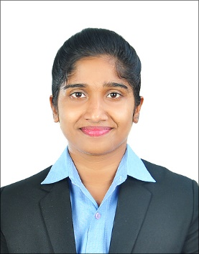

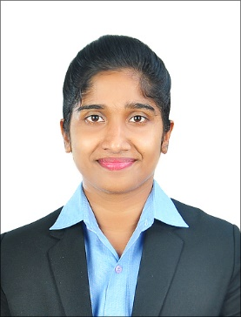

**AKSA SARA VARGHESE**

* aksasara199@gmail.com
* +91-9544497815,+91-9946931373

# Objective

Seeking a position in a progressive organization where I can employ my skills and ability that offers professional growth along with the organization through continuous learning and team work.

# Education

* Graduation : Bachelor of travel and tourism.
* Higher Secondary : 61% (2012-14)
* Secondary : 78% (2011-12)

# Professional Qualification:

* IATA Foundation in Travel and Tourism with Galileo
* IATA DGR, category-6
* Diploma in Airline and Airport Management
* Diploma in Air Cargo Rating
* Galileo-LEVEL 2(Automated Ticketing Module)
* Amadeus-Basic

**Linguistic Ability:** English, Malayalam,Hindi

**Hobbies:** Music and Making Flowers

**Passport Details:**

Passport No. :P2267451

Date of Issue : 29/02/2016

Date of Expiry : 28/02/2026

Place of Issue : Kozhikode

**Personal Details**:

Date of Birth : 18-02-1997

Gender : Female

Nationality : Indian

Religion : Christian

Father’s name : P K Varghese

Mother’s name : Elsy Varghese

Permanent address : Puthenpurakkal (H), Mandad (PO),

Muttil, Kalpetta, Wayanad, Kerala

PIN:673122

**DECLARATION**

I hereby declare that the information furnished above is true to the best of my knowledge and I accept the responsibility for any misrepresentation.

Date:

Place:Wayanad AKSA SARA VARGHESE