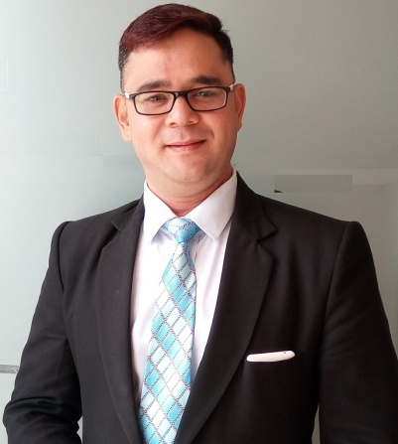

**Anil Kumar R Rawat**

**Objective: -**

To start afresh beginning in the world of corporate and giving them what I have learnt in years and would learn from new generation what I have missed because of ignorance so as to help everybody to make the world better place to live.

To get a challenging position in an organization where my knowledge and skills will be used to utmost and to thrive in challenging environment

**Experience**

**1st Jan-23 to till**

**Prakriti Resort Vadodara**

**as a GM-Operations**

**1st Oct. 2018 To 30 Dec-23**

**Y.C.S. Baroda PVT. LTD. Site {Huntsman international (I) Pvt. Ltd.}**

**As a Zonal Operations Manager (Padra Zone)**

**Roles & Responsibilities**

* Responsible For Menu Planning
* Responsible for Food Quality & Teasing
* Relationship management
* Manpower utilization
* Meeting with other company HR Person Regarding Business Development
* Center kitchen coordination with HOS,s
* Vendor Or Suppler Management

**01-** **February 2016 to 25th Sep.-2018 Prakriti Resort Vadodara as a Manager-Operations**

**Roles & Responsibilities**

* Support and work with Dept Heads in all aspects of operations of this hotel.
* Ensure the premises are in operative condition to receive & serve the guests.
* Monitor the purchase / indent / requisitions of each department,
* Randomly inspecting the stores (F & B / Kitchen) to check the stock in hand (quality, par stock levels, expiry etc) with the F & B Manager & Chef.
* Monitor the co-ordination between all departments for smooth & efficient operations.
* Assessing and reviewing customer satisfaction and service recovery process.
* Identifying staff learning needs and assisting with development
* Monitor and maintain operation & overhead cost in order to maintain maximum revenue to the organization.
* Be 24X7 available on call to resolve any urgent problems & emergencies.
* Responsible for the overall management of the operation of the hotel.

**June ’2014 to Jan 2016**

**Moti Mahal (The Tandoori trail)**

**Restaurant Manager**

**Roles & Responsibilities**

* Responsible for recruiting, maintaining and enriching of staff.
* Responsible for training the staff to give quality service.
* Taking care of every operational aspect.
* Setting up sections, standard operating procedures

**March 2011 to June-2015**

**The Akshaya Patra Foundation**

**As Manager-Production.**

**Roles & Responsibilities**

* Menu planning and implementation.
* Overall production planning, execution and control.
* Relationship management
* Manpower utilization
* Awareness about all quality functions related to production
* Successful handling of meetings
* Six sigma awareness
* ISO – 22000 awareness
* Kaizen awareness

FSTL:

* Food safety team leader:
* Good knowledge of MR 1- 13.

**Feb. 2008 to 26 Feb.2011**

**Mantraa,**

**Operation Manager- Vadodara.**

**Roles & Responsibilities**

* Improve the operational systems, processes and policies in support of organizations mission -- specifically, support better management reporting, information flow and management, business process and organizational planning.
* Play a significant role in long-term planning, including an initiative geared towards operational excellence.
* Development of individual program budgets
* Invoicing to funding sources, including calculation of completed units of service.
* Disbursement of checks for agency expenses.

**March 2002 – June2006**

**Hotel Savshanti, Vadodara,**

**Asst Restaurant manager**

**Roles & Responsibilities**

Started as steward and then captain and last two years as assistant restaurant manager

* Total charge for group functions, and prepare and present .
* Ensure banquet rooms, restaurants, and coffee breaks .
* Ensure proper centerpieces are displayed on every table.
* Communicate service needs to chefs and stewards throughout functions.
* Inspect the cleanliness and presentation of all china, glass, and silver prior to use. Check in with guests to ensure satisfaction.

**EDUCATION:s**

|  |  |  |  |  |
| --- | --- | --- | --- | --- |
| **Sr. No.** | **Qualification** | **Board/University** | **Year** | **Percentage** |
| 1 | H M | Blue mountain Group of College | 2000 | 70.47% |
| 2 | B A | Garhwal University | 2005 | 50% |
| 3 | Intermediate | U.P. board | 1999 | 66% |
| 4 | High School | U.P. board | 1997 | 65% |

**Other Experience**

* **Internal Auditor** **Certificate DNV**
* **Properly Execute Training Program**
* **Lean Six Sigma Green Belt**
* **5S Standard Knowledge**
* **Safety and Hazard Training**
* **Food Safety Management Training**
* **Work with ISO 22000**

**Computer Proficiency:-**

Having operating knowledge of MS-Word, Excel, Power Point , good knowledge of Corel Draw & Internet Access.

**PERSONAL DETAILS:**

**Date of Birth:** 13th July 1979

**Place of Birth:** Dehradun (Uttarakhand)

**Languages:** English, Hindi, and Gujarati

**Nationality:** Indian

**Marital status:** Married

**Permanent Address: -** Block No.:-J/404,

Gunatit Residency Opp.Gayatri Sch.

Gotri Rd.Village Vadodara (MCorp+OG)

Gujarat India.

Contact no. +919824362478

Email: [anil.rawat43@gmail.com](mailto:anil.rawat43@gmail.com)

**Present Salary:** 82 K CCT+ Petrol allowance (As per the bill) + Mobile bill expenses.