**PERSONAL Yogendra Singh**

# INFORMATION

 234/A , D - Block , Shyam Vihar , Phase-1 , South West Delhi Najafgarh, Pin

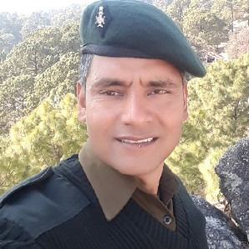Code -110043

 9542629447

 negi.yogendra9101@gmail.com

Date of Birth : 03/06/1982

Marital Status : Married

Nationality : Indian

|  |  |
| --- | --- |
| Known Languages | : Hindi , English , Garhwali |

|  |  |
| --- | --- |
| **TECHNICAL SKILLS** | Certificate in security Of strategic installations . Diploma in security management. Associate degree in security. advanced diploma in arts.  Security training certificate. Certificate in housekeeping supervisor. Certificate in first Aid.  Ability to work under pressure. Self motivation.and leadership Decision making.  Communication. Time management . |

**EXPERIENCE Ex Indian Army .** *05/01/2002 - 31/01/2019*

17 Yrs experience of Security .

Security supervisor.

Manpower management.

Team leadership.

Event management. Team Motivator.

**Indian army ( NDA PUNE )** *01/02/2013 - 31/09/2013*

Assistant of quater master

Office administration ,maintain input and output record

|  |  |
| --- | --- |
| **Indian army**  BFNA  Battle field nursing assistant. FIRST AID  **Indian Army**  Intelligence service | *01/02/2009 - 30/09/2011*  *01/01/2012 - 01/01/2013* |
| **University of Delhi**  B.A  48.33    **Indira Gandhi national open university**  Graduate diploma in security management  78%    **Indira Gandhi national open university**  Pursuing M.A. 2nd year in industrial psychology | 2012  2013 |
| Security/surveillance service. Security /detectives  Sports (walking, running , exercise, bad minton)  Reading, writing  Art Music (Playing , listening )  Job related activities  Volunteer work |  |

# EDUCATION

# INTERESTS

|  |  |
| --- | --- |
| **ACHIEVEMENTS & AWARDS** | Gold medal in cross country, Boxing and debate competition 2008 Sena seva medal  Best student in battle field nursing assistant course "FIRST AID " |

|  |  |
| --- | --- |
| **PERSONAL STRENGTHS** | Ability to learn from mistakes .  Creative thinking. Task prioritization Discipline and determination.  Dedication and enthusiasm.  Interpersonal skills and respectfullness. |