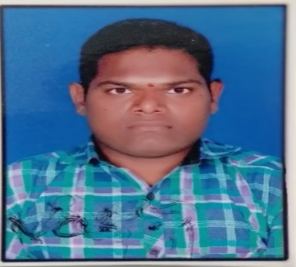**GEETLA SRINIVAS REDDY**

**H.NO 21-333-1**

**KAKATIYA COLONY**

**V: RAMAKRISHNAPUR**

**M: MANDAMARRI**

**D: MANCHERIAL**

**S: TELANGANA**

**PINCODE 504301**

**EMAIL ID:** [**geetla1987@gmail.com**](mailto:geetla1987@gmail.com)

**Contact no: 8522809562**

**Carrier objective:**

Looking forward to join in a reputed organisation where my abilities are potential and properly utilized. To be an expert in my area of work, with passion for challenges innovation and working with people and communities.

**Educational qualifications:**

2009-2011: M.B. A (Master of Business Administration)

From Satavahana University Karimnagar

2005-2008: B.COM (Bachelor of Commerce)

From Mims Degree College Mancherial

2003-2005:10+2 C.E.C (Civics, Economics, Commerce)

From C.V. Raman junior college Ramakrishnapur

2002-2003:S.S.C (Board of Secondary Education)

From Bl. Alphonsa Convent High School Ramakrishnapur.

**Technical education:**

Operating system Windows XP, windows 7, 8 & 10

Packages MS Office 2003, 2007, 2010

Accounting Tally erp9

Certificate Computer assistance.

**Work experience:**

Worked as computer operator in **Sangamithra degree college jamikunta for** 2012 TO 2015

Worked as computer operator in **mother Theresa e/m high school mandamarri** 2015 june to 2016 April

Worked as Logistics Executive **YOKOHAMA INDIA PRIVATE LIMITED HYDERABAD** 2016 Feb TO 2021 April

**Job description as logistics executive 2016 to 2021**

Planning and managing logistics, warehouse, transportation and customer service.

Directing optimizing and coordinating full order cycle

Liaising and negotiating with suppliers, manufactures and suppliers,

Billing and dispatching maintain stocks in go down raising invoices and dealers suppling

Goods.

**Skills:**

I am a quick learner

Good communication skills

Adaptability, creativity, collaboration

**Hobbies:**

I love playing chess, caroms and listening music

I like social works

**Bio data**

Father name : Geetla sanjeeva reddy

Date of birth : 18-07-1987

Nationality : Indian

Marital status : Un married

Permanent address : H.no 21-333-1

Kakatiya colony

V: Ramakrishnapur

M: Mandamarri

D: Mancherial

Pin code: 504301

Physical handicapped : Ortho Handicaped

Languages known : Telugu, Hindi, English

**DECLARATION**

I hereby declared that the above furnished details are true and best of my

Best experience knowledge

Date: (Geetla Srinivas Reddy)

Place: